15.1: Volumes of Cylinders

Find the volume of the cylinder. Round your answer to the nearest tenth.

1. 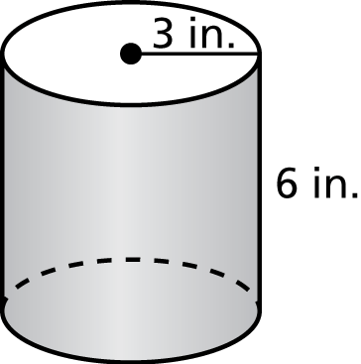 2. 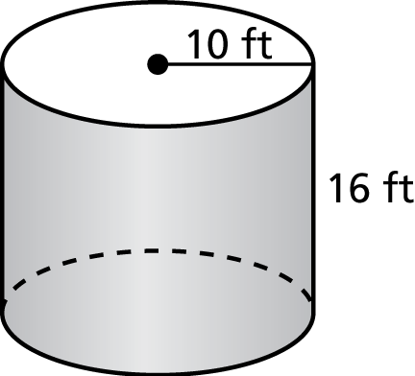

3. 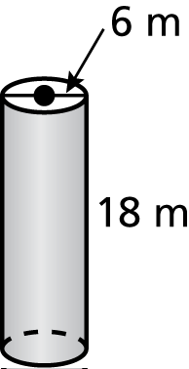 4. 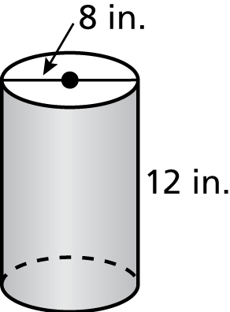

PRACTICE:

Find the volume of the cylinder. Round your answer to the nearest tenth.

1. 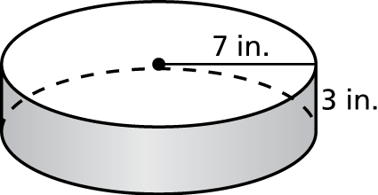 2. 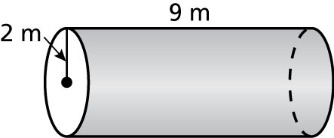

3. 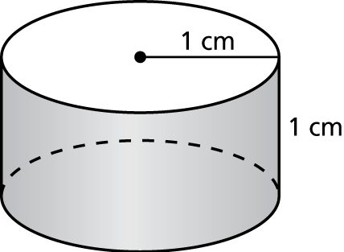 4. 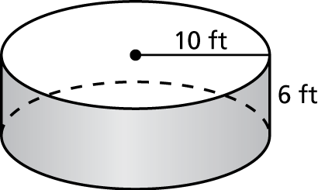

5. 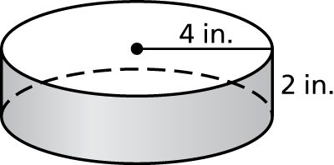 6. 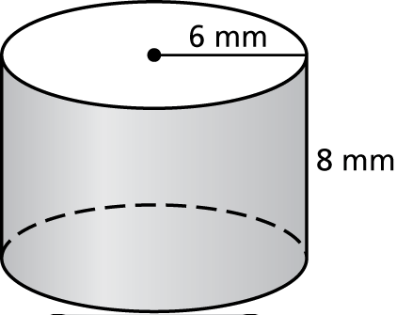

7. A water tank is in the shape of a cylinder with a diameter of 20 feet and a height of 20 feet. The tank is 70% full. About how many gallons of water are in the tank? Round your answer to the nearest whole number. 

8. A cylinder has a surface area of 339 square centimeters and a radius of 6 centimeters. Estimate the volume of the cylinder to the nearest whole number.

9. How does the volume of a cylinder change when its diameter is doubled? Explain.