13.5: Graphing Linear Equations in Standard Form

Standard Form: ax + by = c, where a and b are not both zero; no fractions nor decimals for a, b, and c

Examples:

Write the linear equation in slope-intercept form.

1.  2. 

Graph the linear equation. Use a graphing calculator to check your graph.

3.  4. 

Use the graph to find the *x*- and *y*-intercepts.

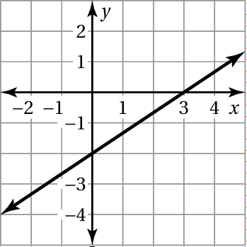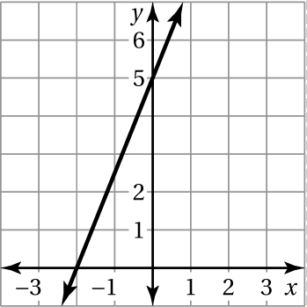 5. 6.

Graph the linear equation using intercepts. Use a graphing calculator to check your graph.

7.  8. 

9. The total amount of fiber (in grams) in a package containing *x* apples and *y* oranges is given by the equation 

a. Find and interpret the *y*-intercept.

b. Find and interpret the *x*-intercept.

c. How many grams of fiber does an orange contain?

d. How many grams of fiber does an apple contain?

e. Is it possible for the package to contain 15 apples? Explain.

10. You have two jobs. You earn $8 for each hour *x* that you work as a restaurant host and $6 for each hour *y* that you work as a hair washer. Your earnings for the pay period are $144.

1. Write an equation in standard form that models your earnings.
2. Find the *x*- and *y*-intercepts.
3. Graph the equation.

d. You worked 10 hours as a hair washer. How many hours did you work as a host?