Name Date

Test A

Chapter

5

Write the ratio. Explain what the ratio means.

Answers

1.

2.

3. See left.

4. See left.

5.

6.

7.

8.

9.

10.

11.

12.

13.

14.

15. See left.

16. See left.

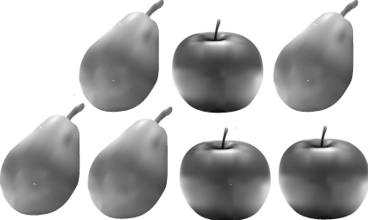 1. golf balls to golf tees 2. apples to pears

Find the missing values in the ratio table. Then write the equivalent ratios.

|  |  |  |  |
| --- | --- | --- | --- |
| Pencils | 6 | 18 |  |
| Erasers | 2 |  | 22 |

3. 4.

|  |  |  |  |
| --- | --- | --- | --- |
| Clients | 3 |  | 6 |
| Hours | 12 | 4 |  |

Write a rate that represents the situation.

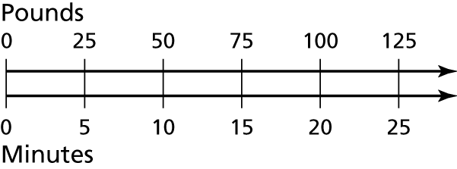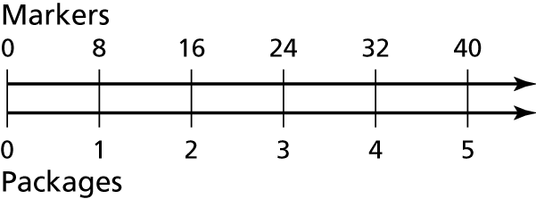 5. 6.

Write a unit rate for the situation.

7. 12 goals in 3 hours 8. 1200 calories in 3 liters

Determine which is the better buy.

|  |  |  |
| --- | --- | --- |
| Hand Soap | A | B |
| Cost (dollars) | 1 | 4 |
| Fluid ounces | 8 | 50 |

|  |  |  |
| --- | --- | --- |
| Beef | A | B |
| Cost (dollars) | 7.38 | 9.57 |
| Pounds | 2 | 3 |

9. 10.

Write the fraction or mixed number as a percent.

11.  12. 

Find the percent of the number.

13. 28.3% of 100 14. 17% of 40

Find the whole. Explain your method.

15. 25% of what number is 15? 16. 70% of what number is 105?

Name Date

Test A **(continued)**

Chapter

5

Complete the statement. Round to the nearest hundredth if   
necessary.

Answers

17. See left.

18. See left.

19.

20.

21.

22.

23.

24.

25. a.

b.

26.

17.   in. 18.   L

19. For a class trip, the teachers would like to have one adult for every   
10 students. There are 190 students on the trip. How many adults   
should go on the trip?

20. An alligator can run at a speed of 13 feet per second on land. At this rate, how far can it run in 3 seconds?

21. Runner A completes 12 laps around a track in 22 minutes. Runner B completes 8 laps in 15 minutes. Which runner had a greater average speed?

In Exercises 22–24, use the table that shows the number of first   
downs in a football game.

|  |  |  |
| --- | --- | --- |
| Team | Cougars | Gators |
| Total First Downs | 16 | 20 |
| By rushing | 8 | 4 |
| By passing | 6 | 15 |
| By penalty | 2 | 1 |

22. What percent of the Cougars’ first downs were by passing? 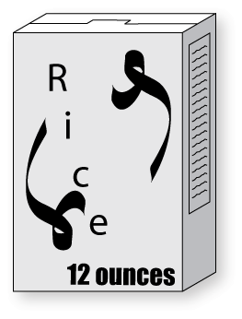

23. Which team had a smaller percent of first downs by penalty?

24. What percent of the Gators’ first downs were by rushing?

25. In a class, 60% of the students are girls. There are 18 girls in the class.

a. How many students are in the class?

b. How many boys are in the class?

26. The following two packages of rice   
cost the same amount. Which is the   
better buy?