4.2: Solving Inequalities Using Addition

An elevator can carry at most 15 people. Write an inequality that models this statement.

Graph the inequality on a number line.

1.  2.  3. 

4.  5.  6. 

Describe a real-life situation that can be represented by the inequality .

Solve the inequality. Graph the solution.

1.  2. 

3.  4. 

5.  6. 

Solve the inequality. Graph the solution.

1.  2. 

3.  4. 

5.  6. 

7.  8. 

9. To stay within your budget, the area of the house and the garage combined is at most 3000 square feet. The area of the garage is 528 square feet. Write and solve an inequality that represents the area of the house.

10. You have $137.26 in a bank account. The bank requires you to have at least $50 in your account or else you are charged a fee. Write and solve an inequality that represents the amount you can write your next check for without being charged a fee.

Write and solve an inequality that represents *x*.

11. The perimeter is less than 20 meters.

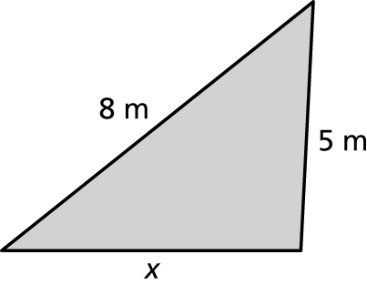

12. The perimeter is at least 18 feet.

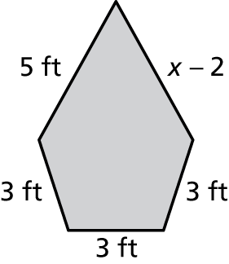

13. You need at least 5000 points to earn a gift card from your bank. You currently have 2700 points.

a. Write and solve an inequality that represents the number of points you need to earn a gift card.

b. You deposit money in your savings account and earn an additional   
400 points. How does this change the inequality?