**11.2: Translations**

Give an example of a translation you could find in your home that is also a tessellation. Explain how it is a translation.

Tell whether the shaded figure is a translation of the nonshaded figure.

1. 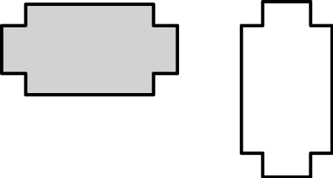 2. 

3.  4. 

Transformation: changes a figure into another figure, and the new figure is called the image.

Translation: a transformation in which a figure slides but does not turn. Every point moves the same distance and in the same direction.

Tell whether the right figure is a translation of the left figure.

1. 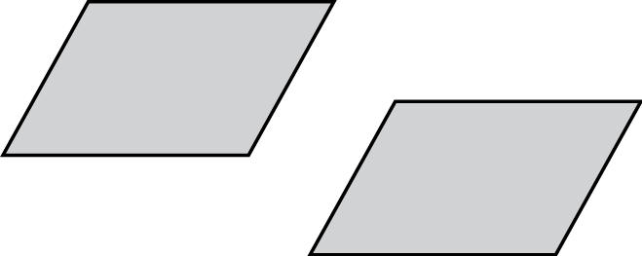 2. 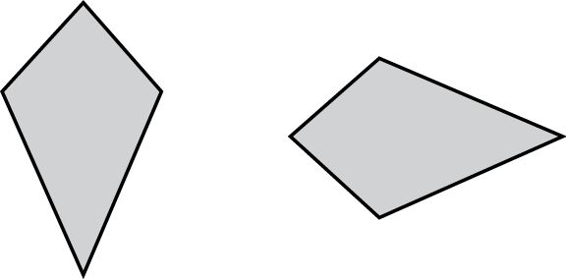

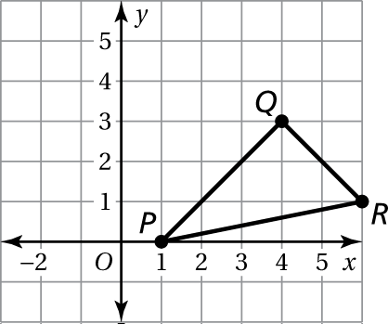 3. Translate the triangle 3 units left   
and 2 units up. What are the   
coordinates of the image?

The vertices of a triangle are  Draw the figure and its image after the translation.

4. 4 units down

5. 2 units right and 1 unit up

6. Describe the translation from the solid line figure to the dashed line figure.

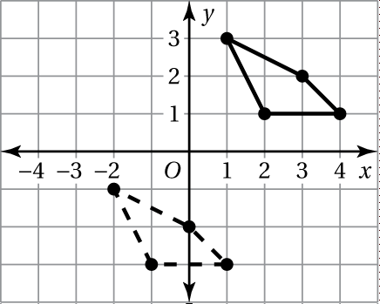

7. In Exercise 6, describe the translation from the dashed line figure to the solid line figure.