9.2: Surface Areas of Pyramids

Regular Pyramid- pyramid whose base is a regular polygon. The lateral faces are triangles.

Slant Height- The height of each triangle

Use the net to find the surface area of the regular pyramid.

1. 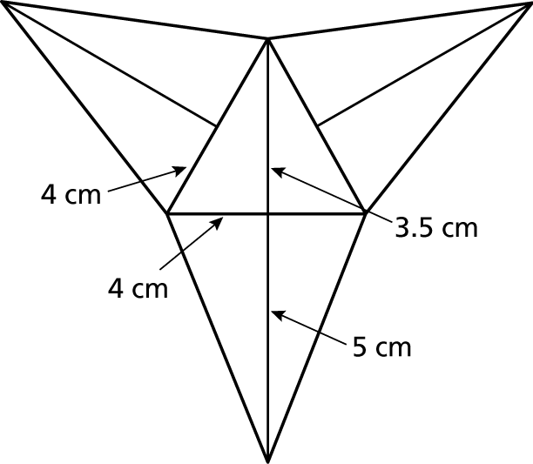 2. 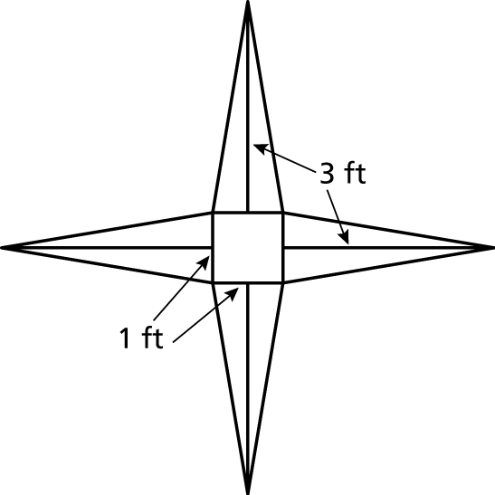

Find the surface area of the regular pyramid.

3. 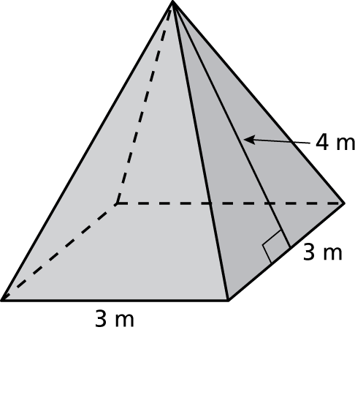 4. 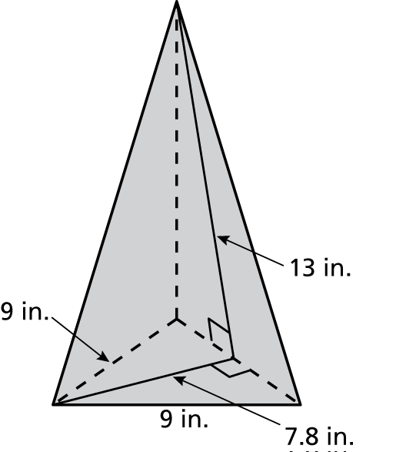

5. Your friend is purchasing an umbrella with a slant height of 4 feet. There are a variety of such umbrellas to choose from.

1. A red umbrella is shaped like a regular pentagonal pyramid with a side length of 3 feet. Find the lateral surface area of the red umbrella.
2. A yellow umbrella is shaped like a regular hexagonal pyramid with   
   a side length of 2.5 feet. Find the lateral surface area of the yellow umbrella.
3. A blue umbrella is shaped like a regular octagonal pyramid with a side length of 1.9 feet. Find the lateral surface area of the blue umbrella.

d. Based on lateral surface areas, would you suggest that your friend pick the umbrella that is her favorite color? Explain.