7.5: Scale Drawings

Scale Drawing:

A proportional, two-dimensional drawing of an object.

Scale Model:

A proportional, three-dimensional model of an object.

Scale:

Gives the ratio that compares the measurements of the drawing or model with the actual measurements.

Ex: 1 in = 10 mi (drawing to the actual) \*Is scale a rate or ratio?

Scale Factor:

A scale where the units are the same

Ex. 1 in : 120 in is simply 1:120

Is scale factor an example of a rate or a ratio?

TRY:

1. Use the drawing of the game court and an inch ruler. Each inch in the drawing represents 8 feet.

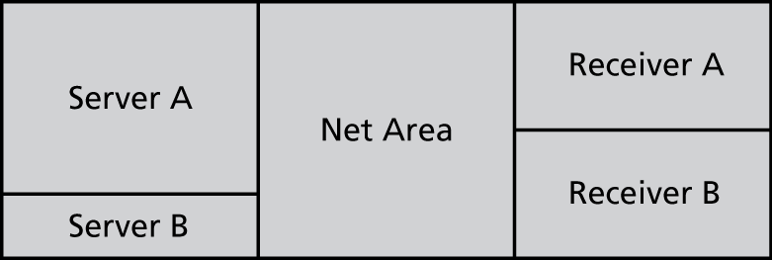

a. What is the actual length of the court?

b. What are the actual dimensions of Receiver A?

c. What are the actual dimensions of the Net Area?

d. The area of Server B is what percent of the area of Server A?

e. What is the ratio of the perimeter of Receiver B to the perimeter of   
Net Area?

f. What is the ratio of the area of Receiver B to the area of Net Area?

g. Are Receiver B and Net Area similar rectangles?

h. The area of Server A is increased by what percent to get the area of   
Net Area?

Find the missing dimension. Use the scale factor 1 : 5.

2. Model: 3 ft 3. Model: 7 m

Actual:  Actual: 

4. Model:  5. Model: 

Actual: 20 yd Actual: 12.5 cm

6. A scale drawing of a rose is 3 inches long. The actual rose is 1.5 feet long.

a. What is the scale of the drawing?

b. What is the scale factor of the drawing?