10.2: Probability

You have one number cube (dice) to roll and a friend has two number cubes to roll. Explain who has   
a better chance of rolling a 4.

Determine whether the fraction is in lowest terms. If not, simplify the fraction.

1.  2.  3. 

4.  5.  6. 

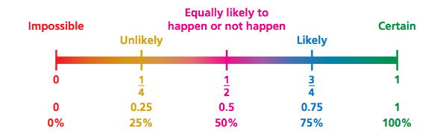

Explain how a weather forecaster might use probability.

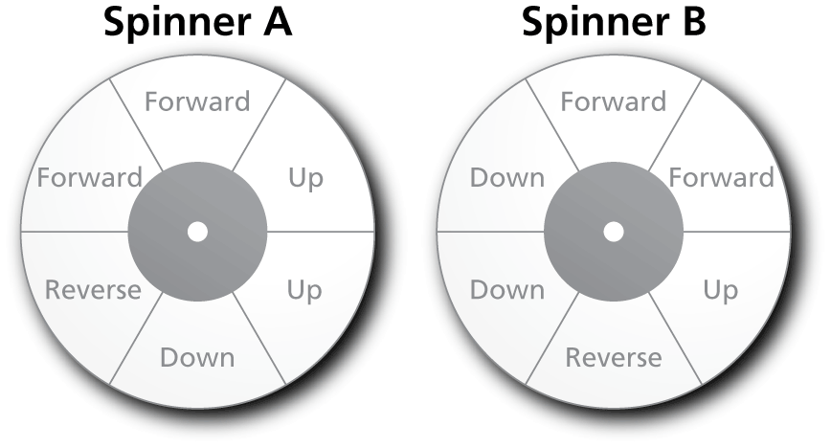You are playing a game   
using the spinners shown.

1. You want to move up.   
On which spinner are   
you more likely to   
spin “Up”? Explain.

2. You want to reverse.   
Which spinner would   
you spin? Explain.

**Probability:**

**A # that measures the likelihood that the event will occur. Probability must be between 0 and 1.**

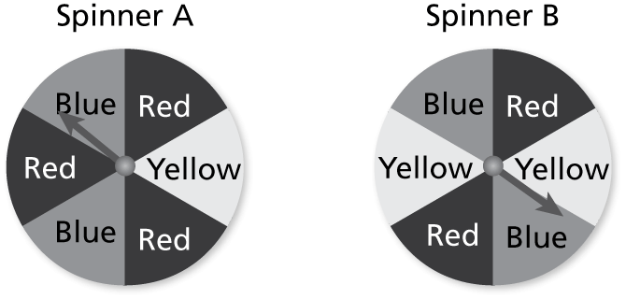You are playing a game using the spinners shown.

1. You want to spin red. Which spinner should   
   you spin? Explain.
2. You want to spin yellow. Which spinner should you spin? Explain.
3. You want to spin blue. Does it matter which spinner you spin? Explain.

Describe the likelihood of the event given its probability.

1. The probability that it will snow today is zero.
2. You make a free throw 70% of the time.
3. Your band marches in  of the parades.

You randomly choose one song from a collection of 4 country songs, 2 jazz songs, 3 rock songs, and 1 pop song. Find the probability of the event.

1. Choosing a jazz song
2. Choosing a pop song
3. *Not* choosing a country song
4. Choosing a blues song
5. Your football team has a 75% chance of winning a game. Your team is scheduled to play 16 games. Estimate how many games your team will win.
6. In a classroom, the probability that the teacher chooses a boy from 20 students is 0.45.
7. How many students are *not* boys?
8. Describe the likelihood of *not* choosing a boy.

13. A box contains ten slips of paper numbered 1 through 10. Find the probability and describe the likelihood of each event.

a. Choosing a number greater than 2

b. Choosing a number that is a multiple of 2

c. Choosing a number that is less than 10