Name Date

Test A

Chapter

2

Multiply. Write the answer in simplest form.

Answers

1.

2.

3.

4.

5.

6.

7.

8.

9.

10.

11.

12.

13.

14.

15.

16.

17.

18.

19.

20.

21.

22.

23. a.

b.

1.  2. 

3.  4. 

Divide. Write the answer in simplest form.

5.  6. 

7.  8. 

**Evaluate the expression. Write the answer in simplest form.**

9.  10. 

Add or subtract.

11.  12. 

Multiply. Use estimation to check your answer.

13.  14. 

15.  16. 

Divide. Use estimation to check your answer.

17.  18. 

19.  20. 

Evaluate the expression.

21.  22. 

23. A professor wants to divide the remaining of the semester evenly   
into six different units.

a. What fraction of the semester should be spent on each unit?

b. The professor drops one unit. What fraction of the semester should be spent on each unit?

Name Date

Test A **(continued)**

Chapter

2

Answers

24.

25.

26.

27.

28.

24. Find the area of the credit card.

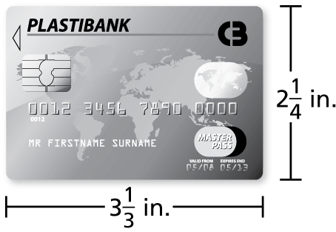

25. A recipe makes cups. The serving size is cup. How many servings does the recipe make?

26. The individual times of four members of a -meter relay team are shown below. Find the the team’s total race time in seconds.

|  |  |
| --- | --- |
| **Runner** | **Time** |
| 1 | 55.2 |
| 2 | 53.9 |
| 3 | 54.1 |
| 4 | 51.7 |

27. The average rainfall in Annette, Alaska, in September is 0.31 inch   
per day. How much rain falls over the course of an average September? (September has 30 days.)

28. A market sells a six-pound bag of potatoes for $6.27 and a 7.5-pound bag of potatoes for $7.65. Which bag of potatoes is a better buy?