**7.1: Adjacent and Vertical Angles**

What is an acute angle?

What is an obtuse angle?

Use a dictionary to look up the non-math definitions of *acute* and *obtuse*. How do the definitions relate to the math definitions?

Identify the angles as *acute*, *right*, *obtuse*, or *straight.*

1. 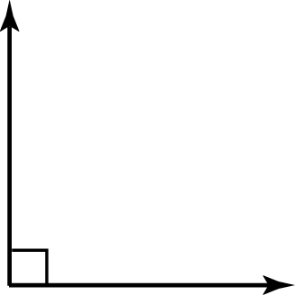 2. 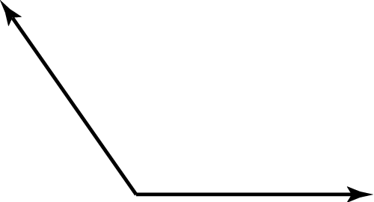

3. 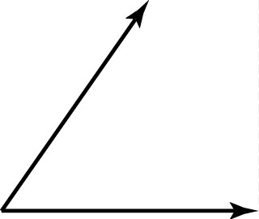 4. TA: C:\replacearts\Red Resources by Chapter\Red Chapter 7 RBC\Arts\PNGs\mscc7_rbc_0701_03.png

Draw two lines that intersect. Explain how to locate a pair of adjacent angles.

Adjacent Angles: angles that share a common side and have the same vertex

Vertical Angles: opposite angles formed by the intersection of two lines

Congruent Angles: angles that have the same measure

Use the figure below.

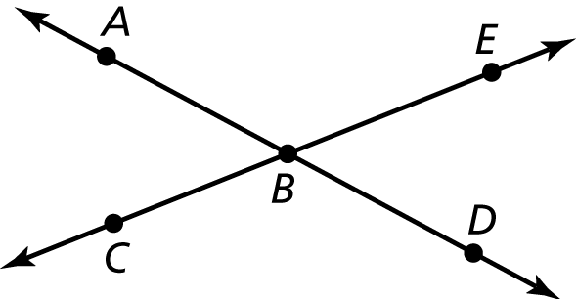

1. Measure each angle formed by the intersecting lines.

2. Name two angles that are adjacent to 

Name two pairs of adjacent angles and two pairs of vertical angles in   
the figure.

1. 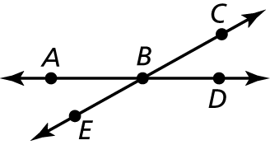 2. 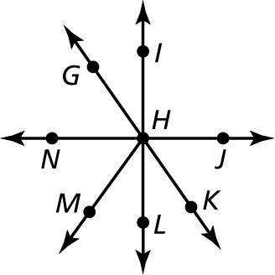

Tell whether the angles are *adjacent* or *vertical*. Then find the value of *x*.

3. 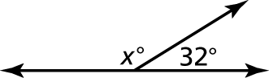 4. 

5. 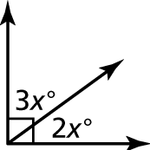 6. 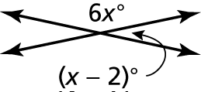

Draw a pair of vertical angles with the given measure.

7.  8.  9. 

10. Draw a pair of adjacent angles with the given description.

a. Both angles are obtuse.

b. The sum of the angle measures is 

c. The sum of the angles measures is 

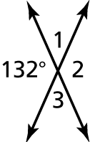 11. What are the measures of the   
other three angles formed by   
the intersection?

7.2: Complementary and Supplementary Angles

Complementary Angles:

Supplementary Angles:

Tell whether the statement is *always*, *sometimes*, or *never* true. Explain.

1. If *x* and *y* are supplementary angles, then *y* is acute.

2. If *x* and *y* are complementary angles, then *x* is obtuse.

Tell whether the angles are *complementary*, *supplementary*, or *neither*.

3. 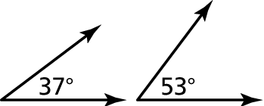 4. 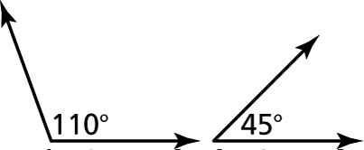

5. 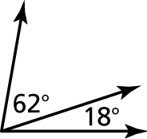 6. 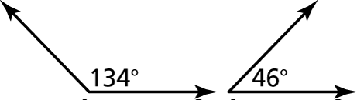

7. Angle *x* and angle *y* are complementary. Angle *x* is supplementary to   
a angle. What are the measures of angle *x* and angle *y*?

Tell whether the angles are *complementary* or *supplementary*. Then find the value of *x*.

8. 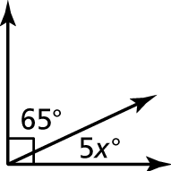 9. 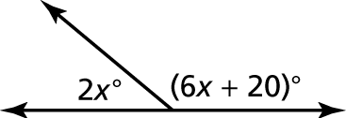

Draw a pair of adjacent supplementary angles so that one angle has the given measure.

10.  11.  12. 

13. Two angles have the same measure. What are their measures if they are also complementary angles? supplementary angles?

12.1: Parallel Lines and Transversals

Transversal:

Interior Angles:

Exterior Angles:

Use the figure to find the measures of the numbered angles.

1. 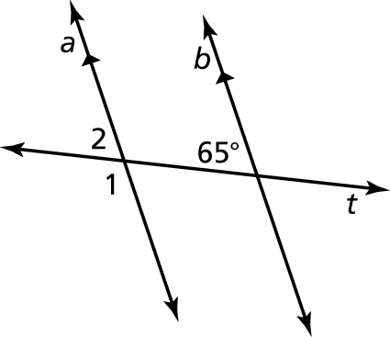 2. 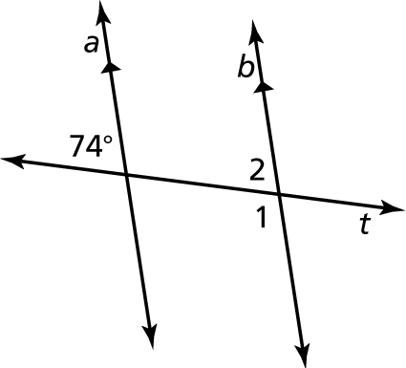

Use the figure to find the measures of the numbered angles. Explain   
your reasoning.

3. 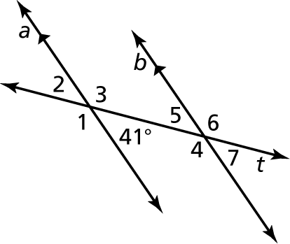 4. 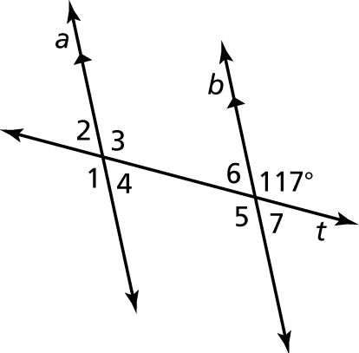

Complete the statement. Explain your reasoning.

5. If the measure of  then the measure   
of 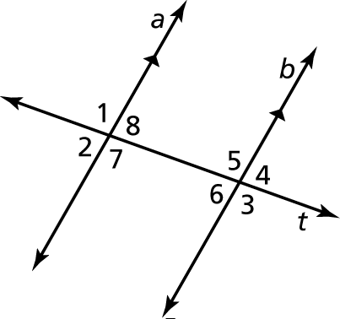

6. If the measure of  then the measure   
of 

7. If the measure of  then the measure   
of 

8. If the measure of  then the measure of 

Correct the following statements about the numbered angles   
by replacing the underlined words with the correct words.

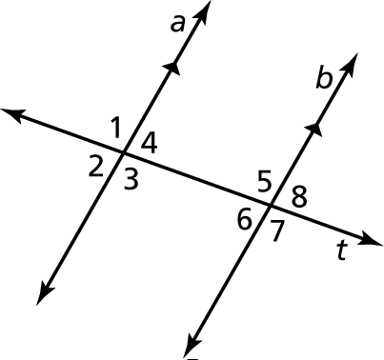

9.  is congruent to   is congruent to    
So,  is supplementary to 

10.  is congruent to   is congruent to    
So,  is congruent to 