**11.3: Reflections**

Words like “racecar” and “deed” are known   
as palindromes. What are some other examples of palindromes? Are palindromes reflections? Explain.

Tell whether the shaded figure is a reflection of the nonshaded figure.

1. 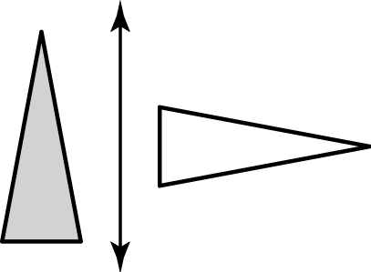 2. 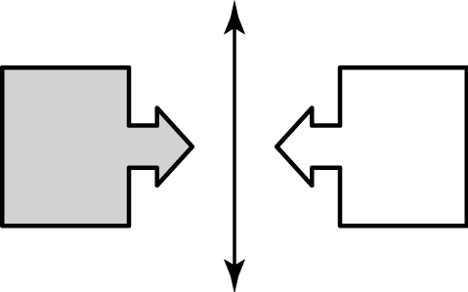

3. 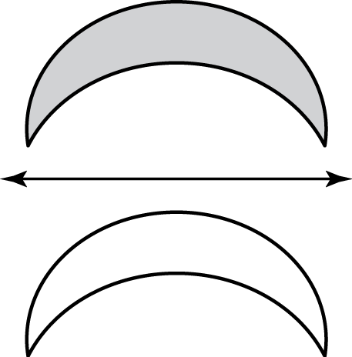 4. 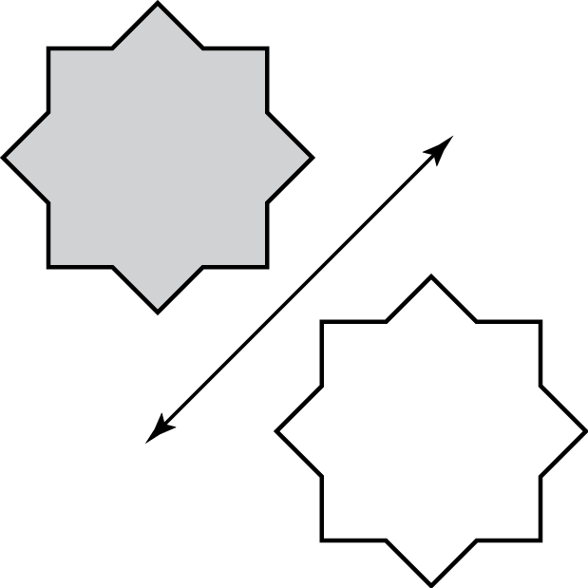

Reflection: or flip, is a transformation in which a figure is reflected in a line called the line of reflection.

A reflection creates a mirror image of the original figure.

Tell whether one figure is a reflection of the other figure.

1. 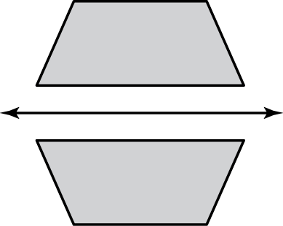 2. 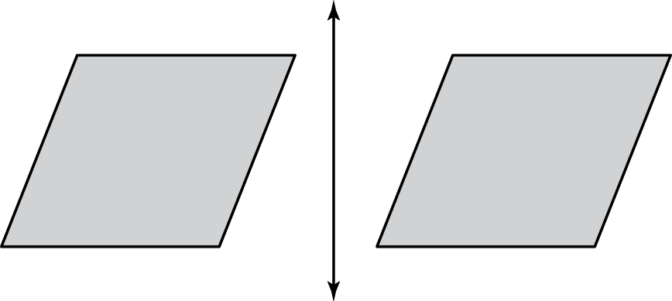

Draw the figure and its reflection in the *x*-axis. Identify the coordinates of the image.

3.  4. 

Draw the figure and its reflection in the *y*-axis. Identify the coordinates of the image.

5.  6. 

7. What does the word MOM spell when it is reflected in a horizontal line?

The coordinates of a point and its image are given. Is the reflection in the *x*-axis or *y*-axis?

8.  9. 

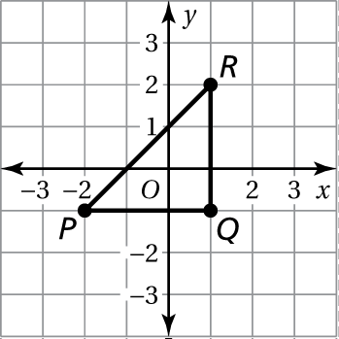 10. Translate the triangle 2 units left and 1 unit up.   
Then reflect the image in the *x*-axis. Graph the   
resulting triangle.

11. A figure is in Quadrant IV. The figure is reflected in the *y*-axis. In which quadrant is the image?