15.2: Volumes of Cones

Find the volume of the cone. Round your answer to the nearest tenth.

1. 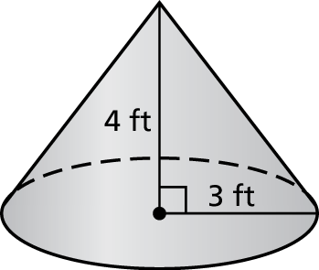 2. 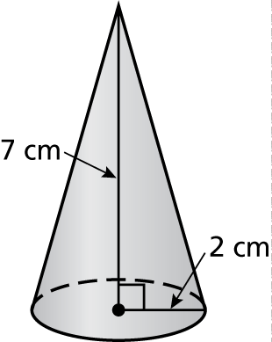

3. 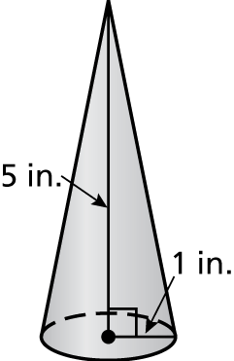 4. 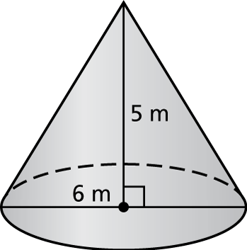

5. 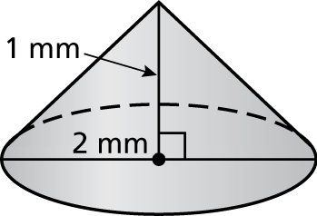 6. 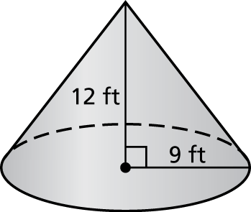

7. The volume of a cylinder is What is the volume of a cone having the same base and same height?

8. A funnel is in the shape of a cone with a radius of 4 inches and a height of 10 inches.

a. Find the volume of the funnel. Round your answer to the nearest tenth.

b. The funnel is filled with oil. How many quarts of oil are in the funnel? Round your answer to the nearest tenth.

Answers

P. 

E. 

S. 

R. 

H. 

X. 

E. 

T. 

P. 

Y. 

E. 

N. 

U. 

S. 

Who Took Tiny Pieces Of Mail Across Country Over A Hundred Years Ago?

Write the letter of each answer in the box containing the   
exercise number.

Find the volume of the cone. Round your answer to the nearest tenth.

1.  2. 

3.  4. 

5.  6. 

7.  8. 

9.  10. 

Find the missing dimension of the cone. Round your answer to the nearest tenth.

11. A sorcerer’s hat is shaped like a cone with a diameter of   
8 inches and a volume of 301.6 cubic inches. What is the height of the sorcerer’s hat?

12. A pine tree is shaped like a cone with a radius of 8 feet and   
a volume of 3887.2 cubic feet. What is the height of the pine tree?

13. A waterspout forms in the shape of a cone with a height   
of 35 meters and a volume of 229.1 cubic meters. What is the diameter of the waterspout?

14. Sand poured from a beach pail forms a cone with a height   
of 32 centimeters and a volume of 3351.0 cubic centimeters.   
What is the radius of the sand poured from a beach pail in   
the shape of a cone?

|  |  |  |  |  |  |  |  |  |  |  |  |  |  |  |  |
| --- | --- | --- | --- | --- | --- | --- | --- | --- | --- | --- | --- | --- | --- | --- | --- |
| 3 | 5 | 8 |  | 12 | 14 | 1 | 6 |  | 10 | 13 | 7 | 11 | 2 | 9 | 4 |
|  |  |  |  |  |  |  |  |  |  |  |  |  |  |  |  |