8.3: Area and Circles

Find the area of the circle. Use 3.14 or 

1. 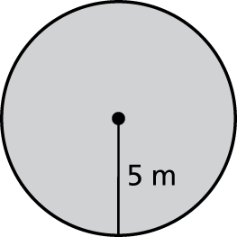 2. 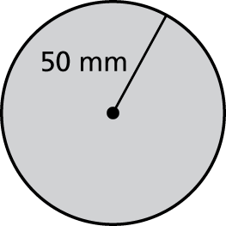 3. 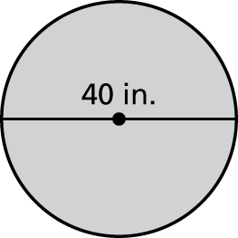

4. 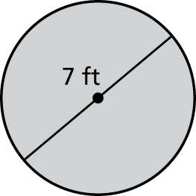 5. 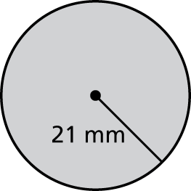 6. 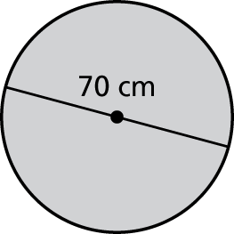

Find the area of the object.

7. 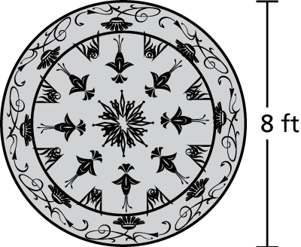 8. 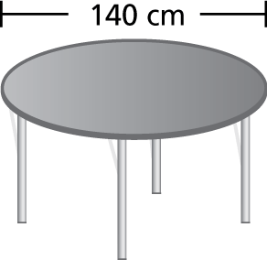 9. 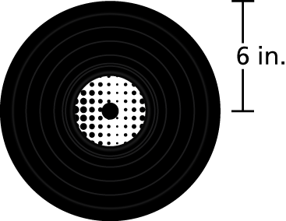

10. You use the compass to draw 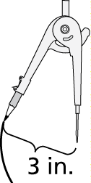  
a circle. What will be the area   
of the circle?

11. What fraction of a square inch is the area of one 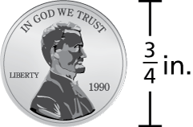  
side of a penny? Use  forWrite your answer   
in simplest form.

12. To make a pizza, you spread pizza sauce over 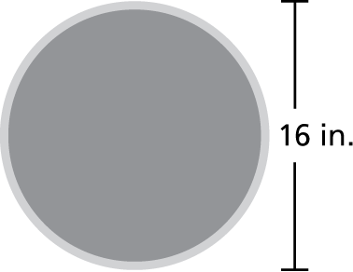  
all but a 1-inch area around the outside edge   
as shown. What area of the crust is covered   
with sauce?