4.4: Solving Two-Step Inequalities

Solve the inequality.

1.  2. 

3.  4. 

5.  6. 

Explain to a partner how to   
find the value of *x* so that the   
area of the rectangle is more   
than 36 square units. Justify   
your answer.

List two values of the variable that satisfy   
the inequality you wrote above.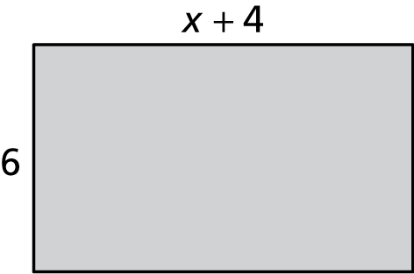

Match the inequality with its graph.

1.  2. 

A.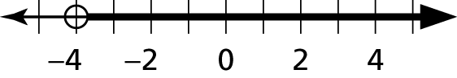 A. 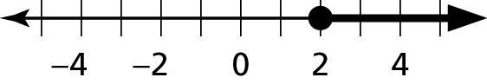

B.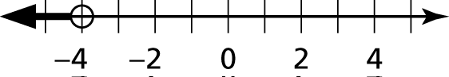 B. 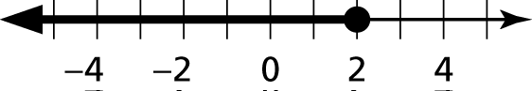

C.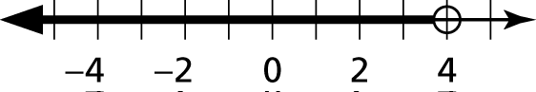 C. 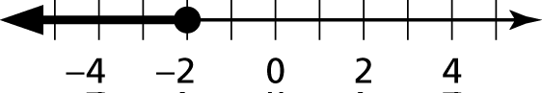

1. You are renting a moving truck for a day. There is a daily fee of $20 and a charge of $0.75 per mile. Your budget allows a maximum total cost of $65. Write and solve an inequality that represents the number of miles you can drive the truck.

Solve the inequality. Graph the solution.

2.  3. 

4.  5. 

6. Write and solve an inequality that represents the values of *x* for which the area of the rectangle will be at least 35 square feet.

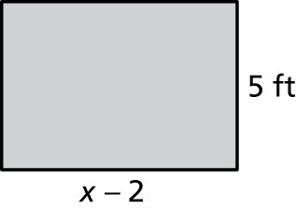

Solve the inequality. Graph the solution.

7.  8.