15.3: Volume of a Sphere

Sphere- the set of all points in space that are the same distance from a point called the center.

Hemisphere- is one-half of a sphere

Find the volume of the sphere. Round your answer to the nearest tenth.

1. 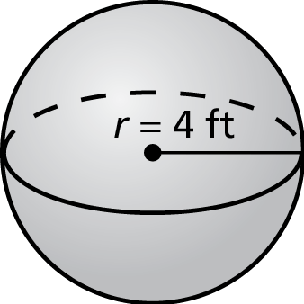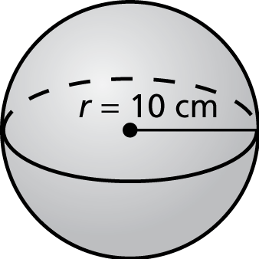 2.

3. 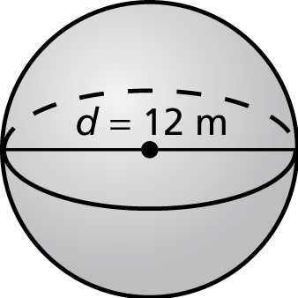 4. 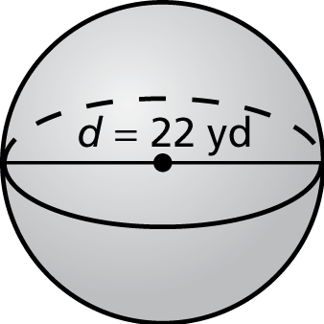

Find the volume of the sphere. Round your answer to the nearest tenth.

1. 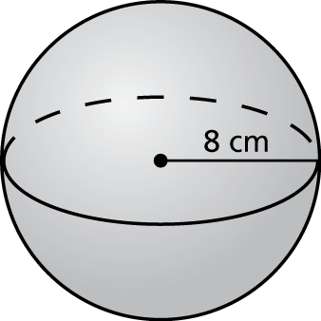 2. 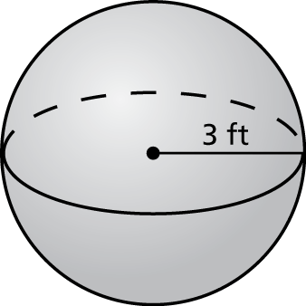

3. 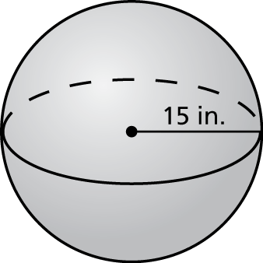 4. 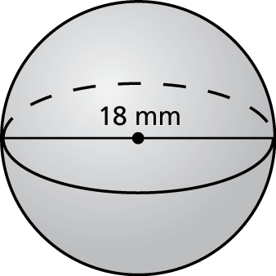

Find the radius of the sphere with the given volume.

5.  6. 

7. A fishing bobber has a radius of 0.5 inch. Find the volume of the   
fishing bobber. Round your answer to the nearest tenth.

Find the volume of the composite solid. Round your answer to the   
nearest tenth.

8. 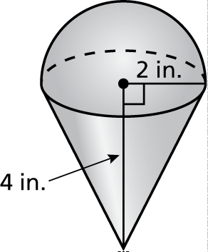 9. 