8.2: Perimeters and Composite Figures

Composite Figure- made up of triangles, squares, rectangles, semicircles, and other 2-dimensional figures

*Read page 324-327 for examples*

Estimate the perimeter of the figure.

1. 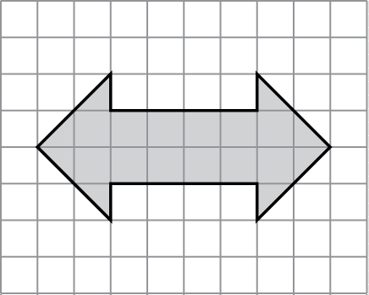 2. 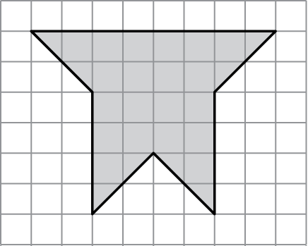 3. 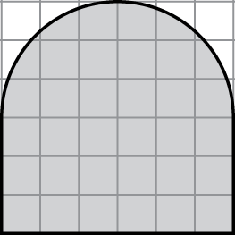

Find the perimeter of the figure.

4. 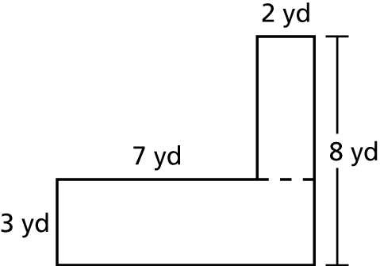 5. 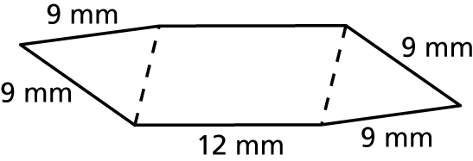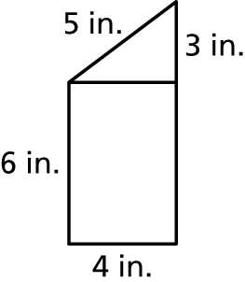 6.

7. 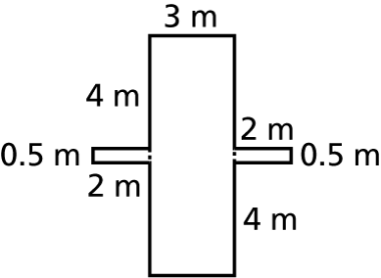 8. 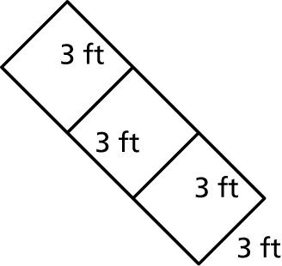 9. 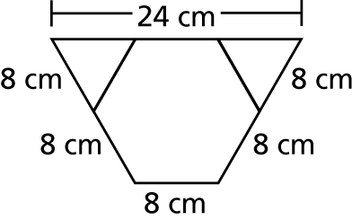

10. A stained glass window has the dimensions 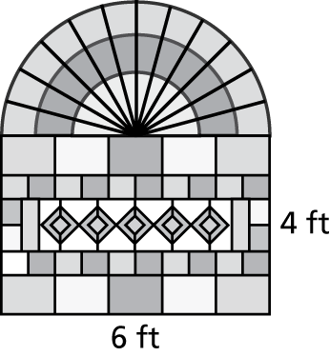  
shown. What is the perimeter of the hole   
that should be cut in the wall in order for   
the window to be installed?

11. The dimensions of a new city park   
basketball court are shown at the 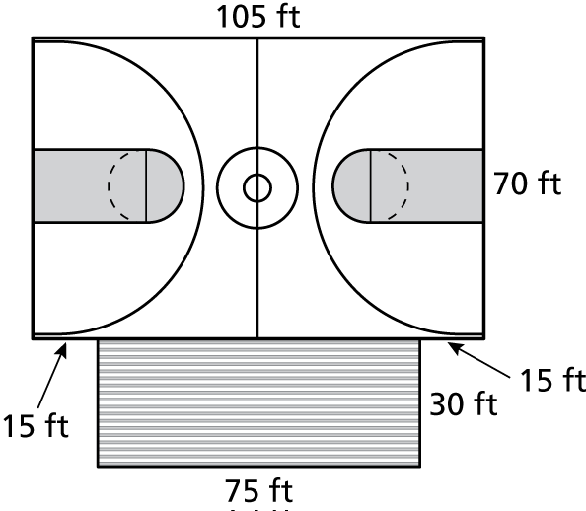  
right. A fence is to be built around   
the court and bleachers. The fence   
costs $8.99 per foot. How much will   
it cost to install the fence?