10.7: Comparing Populations

Measures of Center:

Find the median.

Ex. 5, 7, 8, 8, 12, 12, 14, 17, 21

Median = 12

Mean = Average

Median= the middle number when the order is from least to greatest

Mode: Number that appears the MOST. You can have more than 1 mode or NO Mode

Range (variation) = Smallest number subtracted from the biggest

The tables show the numbers of baskets made by two basketball teams.

|  |  |  |  |  |
| --- | --- | --- | --- | --- |
| Team 2 | | | | |
| 52 | 56 | 65 | 72 | 49 |
| 58 | 49 | 62 | 63 | 54 |

|  |  |  |  |  |
| --- | --- | --- | --- | --- |
| Team 1 | | | | |
| 45 | 52 | 65 | 56 | 70 |
| 56 | 58 | 49 | 55 | 64 |

Upper Quartile – Median of the upper half of data

Lower Quartile – Median of the lower half of data

Interquartile range – The difference of the quartiles

(UQ – LQ)

1. Find the mean, median, mode, range, interquartile range, and mean absolute deviation for each data set.

2. Compare the data sets.

1. The tables show the ages of the players on two basketball teams.

|  |  |  |  |  |  |
| --- | --- | --- | --- | --- | --- |
| Varsity Team Ages | | | | | |
| 18 | 16 | 17 | 16 | 18 | 17 |
| 19 | 18 | 18 | 18 | 18 | 17 |

|  |  |  |  |  |  |
| --- | --- | --- | --- | --- | --- |
| Junior Varsity Team Ages | | | | | |
| 16 | 17 | 15 | 16 | 17 | 15 |
| 18 | 14 | 17 | 16 | 17 | 17 |

1. Find the mean, median, mode, range, interquartile range, and mean absolute deviation for each data set.
2. Compare the data sets.
3. When comparing the two populations using measures of center and variance, would you use the mean and the MAD, or the median and the IQR? Explain.
4. Express the difference in the measures of center as a multiple of the measure of variation.

2. The double box-and-whisker plot shows the number of inches of snow per week in two cities in a 16-week period.

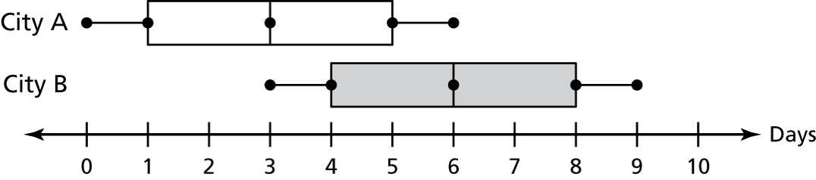

1. Compare the populations using measures of center and variation.

b. Express the difference in the measures of center as a multiple of the measure of variation.