Circles and Circumference

Pi, writtenis the ratio of a circle’s circumference to its diameter. The digits of  do not repeat and continue on without end.

“Piems” are poems that can help you remember to a certain number of digits. The length of each word in a “piem” represents a digit of  For example:

Piem: **Can I find a trick recalling pi easily?**

 **3 . 1 4 1 5 9 2 6**

Write you own “piem” to represent at least the first five digits of 

Circle: the set of all points in a plane that are the same distance from a point is called the Center.

Radius: the distance from the center to any point on the circle

Diameter: the distance across the circle through the center

Circumference: the distance around a circle

Pi (3.14 or 22/7) is the value of c/d for every circle

Find the perimeter of the polygon.

1. 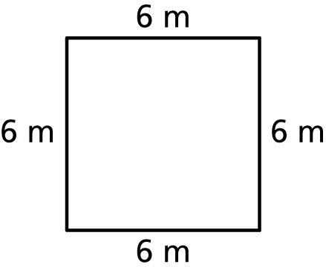 2. 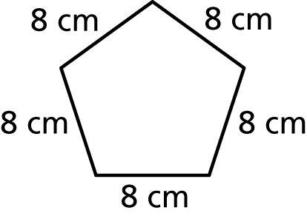 3. 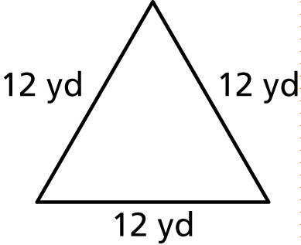

4. 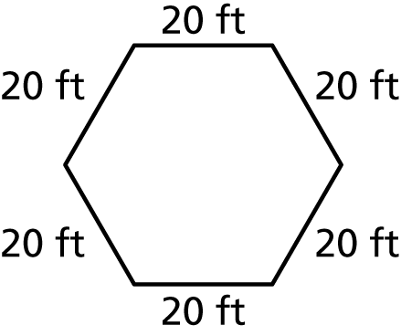 5. 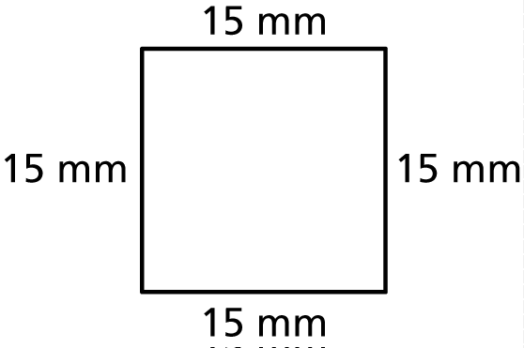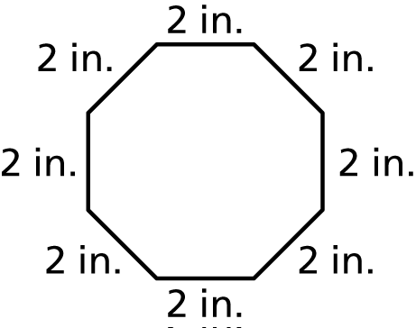 6.

Is it easier to measure the diameter or circumference of a tree trunk? Why?

Is it easier to measure the diameter or circumference of a quarter? Why?

In general, when is it easier to measure the diameter of a circular object?

When is it easier to measure the circumference?

Find the circumference of the circle.   
Use 3.14 or for 

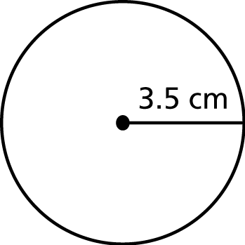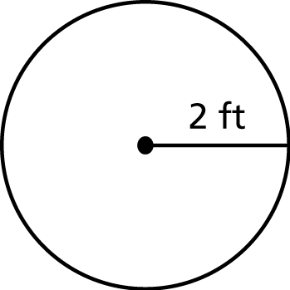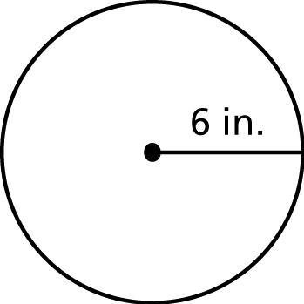 1. 2. 3.

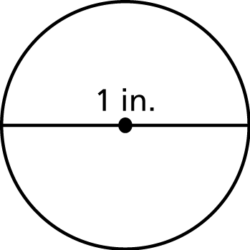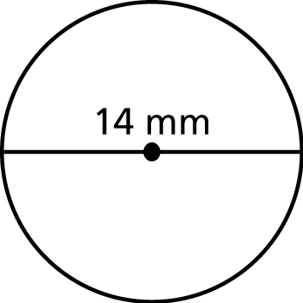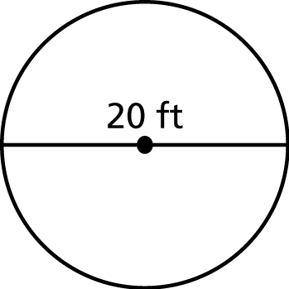 4. 5. 6.

Find the diameter of the circle.

1. 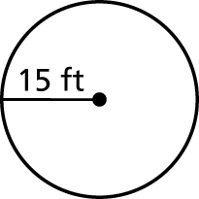 2. 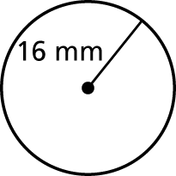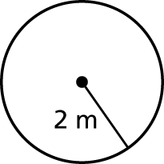 3.

Find the radius of the circle.

4. 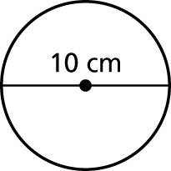 5. 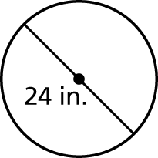 6. 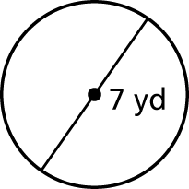

Find the circumference of the circle. Use 3.14 or  for

7. 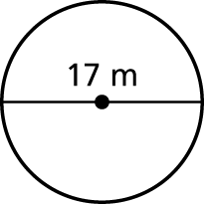 8. 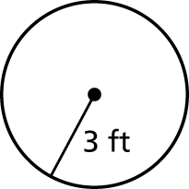 9. 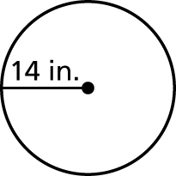

Find the perimeter of the semicircular region.

10. 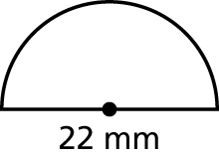 11. 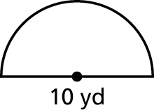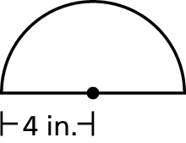 12.

13. A circular ink spot has a circumference of 25.12 millimeters. A minute later, it has a circumference of 75.63 millimeters.

a. Estimate the diameter of the ink spot each minute.

b. How many times greater is the diameter of the ink spot compared to the previous minute?

14. You are enclosing a circular flower garden with a fence that costs $2.99 per foot. The radius of the garden is 7 feet. How much will it cost to buy the fence? 

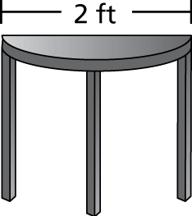 15. Find the perimeter of the semicircular   
tabletop shown at the right.