Name Date

Test A

Chapter

7

Match the equation and the word sentence.

Answers

1.

2.

3.

4.

5.

6.

7.

8.

9.

10.

11.

12.

13.

See left.

14.

15.

16.

17.

18.

19.

20. See left.

21. See left.

1. The sum of a number *n* and 3 is 9. A. 

2. The product of a number *n* and 3 is 9. B. 

3. The quotient of a number *n* and 3 is 9. C. 

4. 9 is 3 less than a number *n*. D. 

Solve the equation. Check your solution.

5.  6.  7. 

8.  9.  10. 

Tell whether the ordered pair is a solution of the equation.

11.  12. 

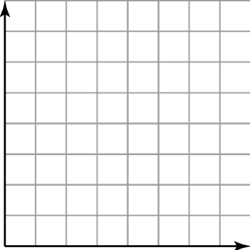 13. Write and graph an equation in two variables that shows the relationship between time and distance.

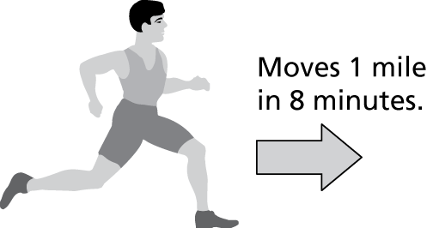

Write the word sentence as an inequality.

**14.** A number *n* is at least 10. **15.** 15 is more than a number *x*.

**16.** Twice a number *a* is less than 3. **17.** A number *s* is no more than 18.

Tell whether the ordered pair is a solution of the inequality.

18.  19. 

Graph the inequality on a number line.

20.  21. 

TA: C:\replacearts\Green Assessment Book\Green Chapter 7 AB\Arts\PNGs\mscc6_ab_0700_06.pngTA: C:\replacearts\Green Assessment Book\Green Chapter 7 AB\Arts\PNGs\mscc6_ab_0700_06.png

Name Date

Test A (continued)

Chapter

7

Solve the inequality. Graph the solution.

Answers

22.

See left.

23.

See left.

24.

25.

26.

27.

28.

29. a.

b.

TA: C:\replacearts\Green Assessment Book\Green Chapter 7 AB\Arts\PNGs\mscc6_ab_0700_06.pngTA: C:\replacearts\Green Assessment Book\Green Chapter 7 AB\Arts\PNGs\mscc6_ab_0700_06.png 22.  23. 

24. A soccer game is 60 minutes long. Forty-one minutes of the game   
have been played. Write and solve an equation to find the number   
of minutes *m* that remain.

Solve for *h*. Check your answer.

25.  26. 

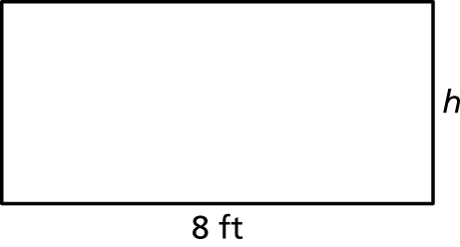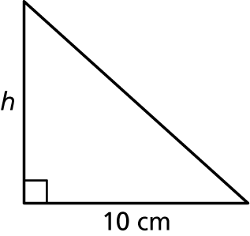

 27. A mobile phone plan has a base fee   
of $50 per month. The monthly cost   
increases by $10 for every gigabyte   
of data used. Write and graph an   
equation in two variables that   
represents the total monthly cost   
of the plan.

28. A disc will hold up to 62 minutes of music. The songs on the disc are 24 minutes long altogether. Write and solve an inequality to find how many more minutes of music you could add to the disc.

29. An acting improvisation class divides into 6 teams that each have at most 4 students.

a. Write and solve an inequality to represent the number of students   
in the class.

b. Each team has at least two students. Could there be 20 students in the class? Explain why or why not.