Name Date

Test A

Chapter

4

Find the area of the parallelogram, triangle, or trapezoid.

Answers

1.

2.

3.

4.

5.

6.

7. See left.

8. See left.

9.

10.

11.

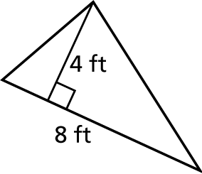 1. 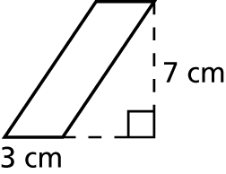 2.

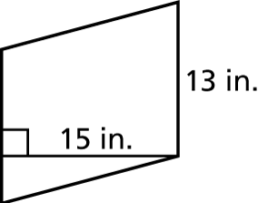 3. 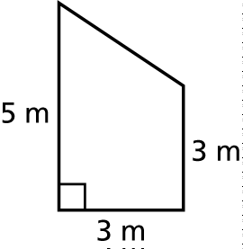 4.

Find the area of the figure.

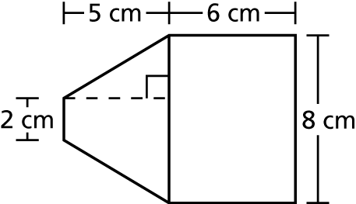 5. 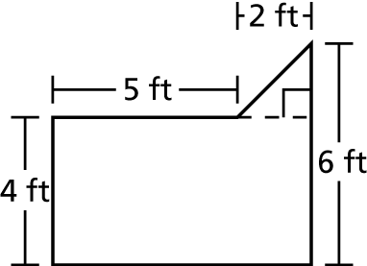 6.

Draw the polygon with the given vertices in a coordinate plane.

7. *A*(6, 4), *B*(4, 5), *C*(3, 1) 8. *D*(1, 5), *E*(4, 5), *F*(5, 3), *G*(2, 3)

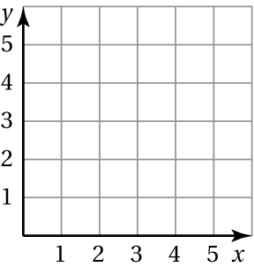 

Find the perimeter and the area of the polygon with the given vertices.

9. *H*(3, 2), *I*(5, 2), *J*(5, 7), *K*(3, 7) 10. *P*(1, 2), *Q*(1, 6), *R*(8, 6), *S*(8, 2)

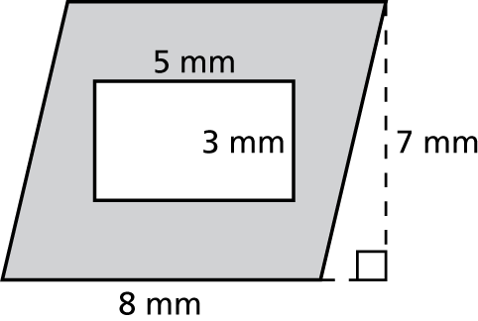 11. Find the area of the shaded region.

Name Date

Test A **(continued)**

Chapter

4

12. The base of a parallelogram is 13 yards and the height is 10 yards.   
What is the area?

Answers

12.

13.

14.

15. a.

b.

c.

16.

17.

18.

13. A trapezoidal window is 8 feet tall and has base lengths of   
1 foot and 7 feet. What is the area of the window?

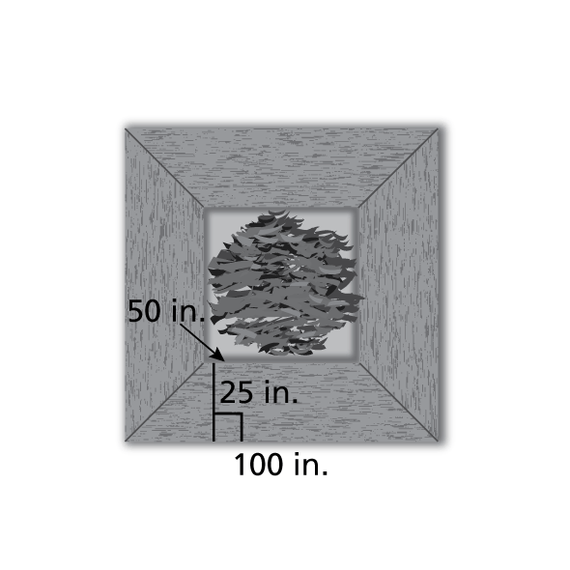 14. The base of a triangle is 8 centimeters and the height is 20 centimeters. What is the area of the triangle?

15. A bench around the base of a tree is in the   
shape of a square and is made up of four   
trapezoids of the same size.

a. What is the perimeter around the   
outside of the bench?

b. What is the area of one trapezoid?

c. What is the area of the entire bench?

16. The front of a partially collapsed barn is shown below. Find the area   
of the front of the barn.

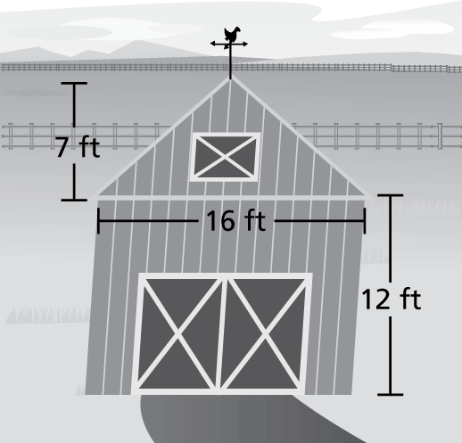

17. On a state map, the vertices of the boundary of a county are *A*(10, 30), *B*(65, 30), *C*(65, 60), and *D*(10, 60). The coordinates are measured in miles. What is the area of the county?

18. The vertices of a swimming pool are *E*(5, 5), *F*(5, 20), *G*(35, 20), and *H*(35, 5). The endpoints of a line that divides the pool into two sections are *J*(15, 5) and *K*(15, 20). The coordinates are measured   
in meters. What is the area of each section?