Name Date

Test A

Chapter

6

Write a positive or negative integer that represents the situation.

1. Sarah lost 3 points on her test.

2. 5 inches of rain fell in April.

Graph the integer and its opposite.

Answers

1.

2.

3. See left.

4. See left.

5.

6.

7. See left.

8. See left.

9. See left.

10. See left.

11.

12.

13. See left.

14. See left.

15. See left.

16.

17. a.

b.

c.

d.

e.

f.

18.

TA: C:\replacearts\Green Assessment Book\Green Chapter 6 AB\Arts\PNGs\mscc6_ab_0600_03.pngTA: C:\replacearts\Green Assessment Book\Green Chapter 6 AB\Arts\PNGs\mscc6_ab_0600_03.png 3. 3 4. 

Order the integers from least to greatest.

5.  6. 

Graph the number and its opposite.

TA: C:\replacearts\Green Assessment Book\Green Chapter 6 AB\Arts\PNGs\mscc6_ab_0600_03.pngTA: C:\replacearts\Green Assessment Book\Green Chapter 6 AB\Arts\PNGs\mscc6_ab_0600_03.png 7.  8. 

Complete the statement using 

9.  10. 

Find the absolute value.

11.12. ****

Complete the statement using 

13.   6 14. 0   15.   

16. One fish is 4 feet below sea level. Another fish is 3 feet below sea   
level. Write each position as an integer. Which integer is greater?

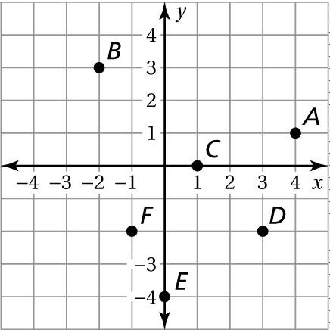In Exercises 17 and 18, use the figure.

17. Write an ordered pair corresponding   
to the point.

a. Point *A* b. Point *B*

c. Point *C* d. Point *D*

e. Point *E* f. Point *F*

18. Which point is located in Quadrant III?

Name Date

Test A **(continued)**

Chapter

6

Plot the ordered pair in the coordinate plane. Describe the location   
of the point.

Answers

19. See left.

20. See left.

21. a.

b.

22. a.

b.

23.

24.

25. a.

b.

c.

26. a.

b.

c.

27. a.

b.

19.  20. 

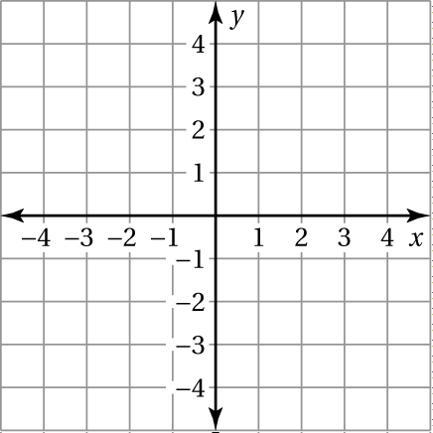

Reflect the point in (a) the *x*-axis and (b) the *y*-axis.

21.  22. 

Reflect the point in the *x*-axis followed by the *y*-axis.

23.  24. 

25. A coal mine worker is 650 feet below the ground in a mine. Another coal mine worker is 7 feet above ground operating machinery.

a. Write an integer for the position of each worker relative to the ground.

b.Find the absolute value of each integer.

c. Which worker is farther from the ground surface?

26. The table shows the profit (or loss) of a company throughout the year.

|  |  |  |  |  |
| --- | --- | --- | --- | --- |
| Quarter | 1 | 2 | 3 | 4 |
| Profit (millions of dollars) |  |  |  |  |

a. In what quarter did the company have the greatest profit?

b. In what quarter did the company have the greatest loss?

c. In what quarter was the company’s profit closest to zero?

27. The pool is located at

a. To get to your house from the pool, you walk 3 blocks west and 1 block   
north. What ordered pair corresponds to the location of your house?

b. What quadrant is your house located in?