13.4: Graphing Linear Equations in Slope-Intercept Form

x-intercept: where the line of a graph crosses the x-axis; occurs when y = 0

y-intercept: where the line of a graph crosses the y-axis; occurs when x = 0

slope-intercept form: a linear equation written in the form y = mx + b, where m is the slope and b is the

y-intercept

Match the equation with its graph. Identify the slope   
and *y*-intercept.

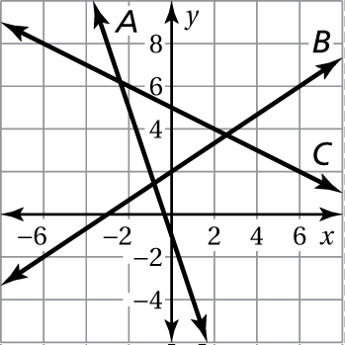 1. 

2. 

3. 

Find the slope and the *y*-intercept of the graph of the linear equation.

4.  5. 

6.  7. 

8.  9. 

10. The depreciated value *y* (in dollars) of a business car after *x* years is



1. Graph the equation.
2. Interpret the slope.
3. Interpret the *y*-intercept.
4. Interpret the *x*-intercept.

Graph the linear equation. Identify the *x*-intercept. Use a graphing calculator to check your answer.

11.  12. 

13.  14. 

15. The amount of fertilizer *y* (in cups) that is needed for *x* square feet of grass is 

a. Graph the equation.

b. Interpret the slope.