9.5: Volumes of Pyramids

Volume of a Pyramid

The volume of a Pyramid is one-third the product of the area of the base and the height of the pyramid.

Find the volume of the pyramid.

1. 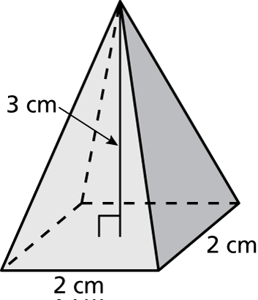 2. 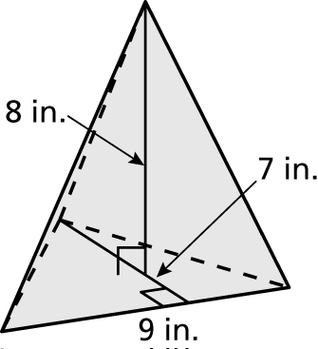

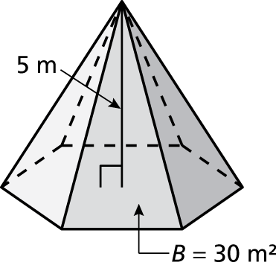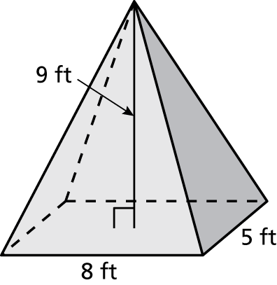

3. 4.

5. A tent is in the shape of a pyramid. The base is a rectangle with a length of 12 feet and a width of 10 feet. The height of the tent is 8 feet. Find the volume of the tent.

6. A sign made of solid wood is in the shape of a pyramid. The base is a triangle with a base of 6 feet and a height of 4 feet. The height of the sign is 7 feet. The wood costs $3 per cubic foot. What is the cost of the sign?

7. Two pyramids with square bases have the same volume. One pyramid has a height of 6 centimeters and the area of the base is 36 square centimeters.

a. What is the volume of the pyramids?

b. The base of the other pyramid has a side length of 3 centimeters. What is the height of this pyramid?

8. How does the volume of a pyramid change when the height is halved?