Name Date

Answers

1.

2.

3.

4.

5. See left.

6. See left.

7.

8.

9.

10.

11.

12.

13.

14.

15.

Test A

Chapter

12

Write the rational number as a decimal.

1.  2. –

Write the decimal as a fraction or a mixed number in simplest form.

3.  4. 

Complete the statement using 

5.  6. 

7. Your skateboard ramp isfeet high. Your friend’s skateboard   
ramp isfeet high. Which skateboard ramp is higher?

Add or subtract. Write fractions in simplest form.

8.  9. 

10.  11. 

Find the distance between the two numbers on the number line.

12. 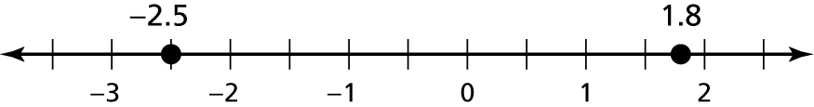

13. 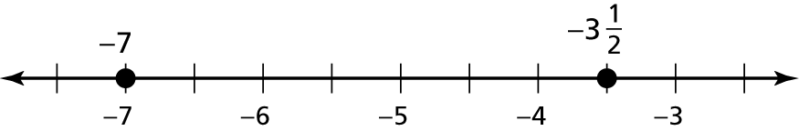

14. A gallon jug of milk isfull. After breakfast the jug isfull. Find   
the difference of the amounts before breakfast and after breakfast.

15. You buy a bag of dog food for $12.59 and a bottle of dog shampoo   
for $4.75. How much more did the dog food cost than the shampoo?

Name Date

Answers

16.

17.

18.

19.

20.

21.

22. See left.

23.

24.

Test A **(continued)**

Chapter

12

Multiply or divide. Write fractions in simplest form.

16.  17. 

18.  19. 

20.  21. 

22. How manypackages of peanuts can be made with 8 ounces   
of peanuts? Explain how you found your answer.

23. Find the perimeter of the rectangle.

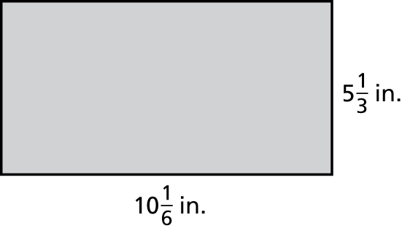

24. A 13.5-gallon gasoline tank is  full. How many gallons will it take   
to fill the tank?