11.4: Rotations

Find the coordinates of the figure after reflecting in the *x*-axis.

1. 

2. 

Give an example of a translation, reflection, and rotation in a basketball game.

Rotation- or turn, is a transformation in which a figure is rotated about a point called the center of rotation.

Angle of rotation- the number of degrees a figure rotates

Tell whether the dashed figure is a rotation of the solid figure about the origin. If so, give the angle and direction of rotation.

1. 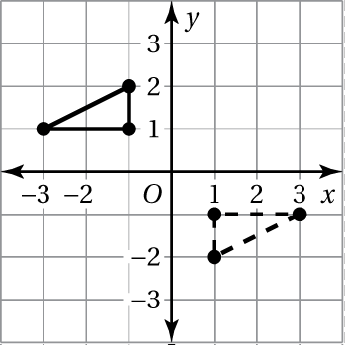 2. 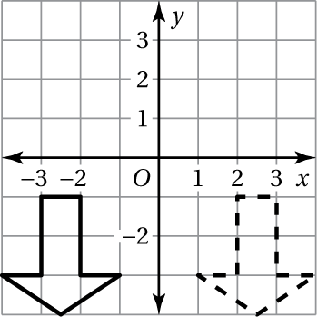

The vertices of a triangle are  Rotate the triangle as described. Find the coordinates of the image.

3.  clockwise about the origin

4.  counterclockwise about the origin

5.  counterclockwise about vertex A

6.  about vertex *C*

Tell whether the figure has rotational symmetry.

7. 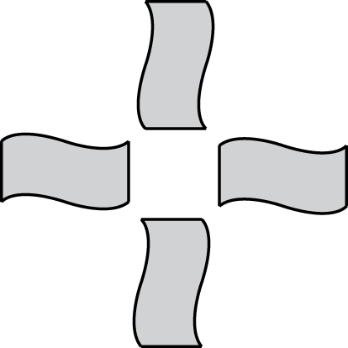

8. 