**Pre-Algebra Final Review**

**Chapter 1: Integers**

Simplify each expression. Show all steps below each problem.



Evaluate each expression if x = 7, y = 3, and z = 9. Show all work below each problem.

2. 2x + (4z – 13) – 5

Solve each equation. Show all work below each problem.

1. 43.4 = 6.2m
2. m + 10 = -2

Solve each inequality. Graph the solution on a number line. Show all work and the graph below each problem.

1. 5g + 1.8 **<** 4.3

1. 4(w – 3) 36

Define the variable for each problem and solve algebraically. Make sure to show the formula where needed. Circle all final answers.

1. A rectangle has a length that is twice its width. Find the area and perimeter of the rectangle if the width is 8 centimeters.

10.) The perimeter of a rectangle is 22.6 meters. If the length of one side is 7.3meters, what is the width of one side of the rectangle?

**Chapter 2: Rational Numbers**

Write the rational number as a decimal.

11.) –

Write the decimal as a fraction or a mixed number in simplest form.

12.) 

Complete the statement using 

13. )

14.) 

Add or subtract. Write fractions in simplest form.

15.)

16.) .

Find the distance between the two numbers on the number line.

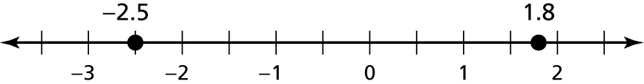

17.)

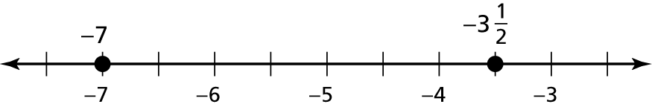

18.)

19.) You buy a bag of dog food for $12.59 and a bottle of dog shampoo   
for $4.75. How much more did the dog food cost than the shampoo?

Multiply or divide. Write fractions in simplest form.

20.) 

21.)

**Chapter 3: Expressions and Equations**

Identify the terms, like terms, constants, and coefficients in the expression.

22.) 

Find the sum or difference.

23.) 

Factor out the coefficient of the variable.

24.) 

25.) Write an expression in **simplest form** that represents the **perimeter**   
of the polygon.

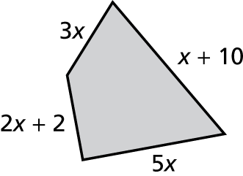

26.) One page of a petition can hold *p* signatures. You were able to   
get people to sign the petition. Your friend was able to   
get people to sign the petition. Write an expression that represents the *total* number of people that you and your friend got to   
sign the petition.

Solve the equation. Check your solution.

27.)

28.) 

Write the word sentence as an equation.

29.) The quotient of 5 plus a number *d* and negative 2 is 14.

Write an equation. Then solve.

30.) The temperature of dry ice is -109.3 degrees. This is 184.9 degrees less than the

outside temperature. What is the outside temperature?

31.) A pack of cardinal flower seeds costs $4, and a pack of petunia   
flower seeds costs $2.50. You buy the same number of packs of   
each type of flower and spend $39. How many packs of each do   
you buy?

**Chapter 4: Inequalities**

Write an inequality for the graph.

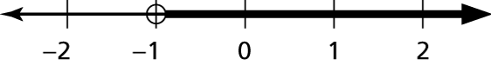32.)

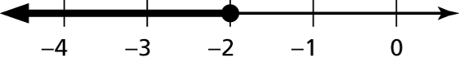33.)

Write the word sentence as an inequality.

34.) A number *x* divided by  is at least 

35.) A number *y* is no more than -8.

Tell whether the given value is a solution of the inequality.

36.) 

37.) A subway ride for a student costs $1.25. A monthly pass costs $35. (write both answers below)

a.) Write an inequality that represents the number of times you must ride the subway for the monthly pass to be a better deal.

b.) You ride the subway about 45 times per month. Should you buy the monthly pass? Explain

Solve the inequality.

38.)

39.)

Solve the inequality. Graph the solution.

40.) 

Write and solve an inequality that represents the value of *x*.

41.) The area is no more than 40 feet.

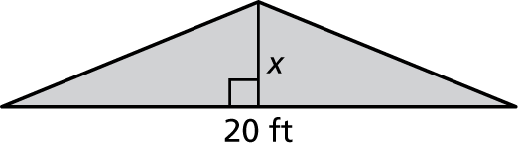

**Chapter 5: Ratios and Proportions**

Read each problem carefully and make sure to solve each problem algebraically to receive full credit. Show all work below each problem.

42.) A scientist is mixing a chemical solution for an experiment. The solution contains ounce of a chemical and ounce saline solution. What is the *unit* *rate* of chemical to saline solution?

43.) A store sells a 1 pound package of turkey for $9. What is the *unit price* of the turkey in the package?

44.) Given the table below, find the *constant of proportionality.*

|  |  |  |  |  |
| --- | --- | --- | --- | --- |
| X | 2 | 4 | 7 | 9 |
| Y | 0.4 | 0.8 | 1.4 | 1.8 |

45.) A recipe that makes 8 servings requires 3 cups of milk. *Write and solve a proportion equation* that can be used to find the number of servings, x, that can be made using 14 cups of milk, based on the recipe.

46.) The table below shows the amounts of cooked rice that can be made using different amounts of dry rice. Based on the information in the table, *how many cups of cooked rice can be made from 1 cup of dry rice*?

|  |  |  |  |  |
| --- | --- | --- | --- | --- |
| Amount of Dry Rice (cups) |  |  | 1 | 1 |
| Amount of Cooked Rice (cups) | 2 | 3 | 5 | 7 |

**Chapter 6: Percents**

Write the percent as a decimal.

47.) 66.7% 🡪

48.) Thursday afternoon between 4:00 and 5:00 you spend  of the   
hour reading email, 0.4 hour doing homework, and 35% of the   
hour doing chores. Write the tasks in order from least amount of   
time to greatest.

Use the table that shows the results of a class poll for #49.

|  |  |  |
| --- | --- | --- |
| Question | Yes | No |
| Do you walk to school? | 18% | 82% |
| Is there a pet in your home? |  |  |
| Do you play on a sports team? | 0.42 | 0.58 |

49.)  of the students live within  mile of the school. Is this greater   
than or less than the portion of students who walk to school?

Write and solve a *proportion* to answer the question.

50.) 35% of what number is 21?

Write and solve an *equation* to answer the question.

51.) 60 cars to 24 cars

Use the percent of change to find the *new amount*.

52.) 820 brushes decreased by 25%

Find the original price, discount, sale price, or selling price.

53.) Original price: $125

Discount: ?

Sale price: $81.25

54.) Cost to store: $32

Markup: 16%

Selling price: ?

An account earns annual simple interest. Find the interest earned, principal, interest rate, or time.

55.) Interest earned: $39.60   
 Principal: ?   
 Interest rate: 11%   
 Time: 6 months

An account earns annual simple interest. Find the *balance* of   
the account.

56.) $250 at 4% for 1 year

57.) The price of your favorite brand of jeans was $35 last month. This month the price is $42. What is the percent of change from last month to this month?

**Chapter 7: Constructions and Scale Drawings**

Tell whether the angles are *adjacent* or *vertical*. Then find the value of *x*.

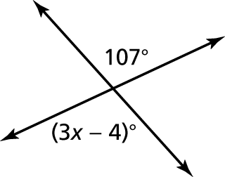

58.)

Tell whether the angles are *complementary, supplementary,* or *neither*.

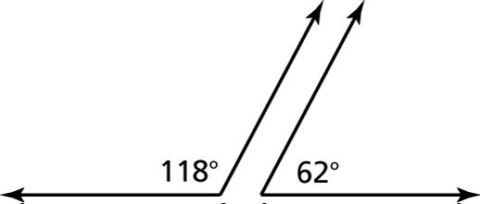 59.)

60.) The measures of two complementary angles have a ratio of 2 : 7. What is the measure of the smaller angle?

Find the value of *x*. Then classify the triangle (according to sides and angles).

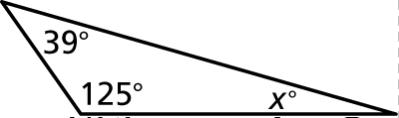

61.)

Classify the quadrilateral. Find the missing angle measure(s).

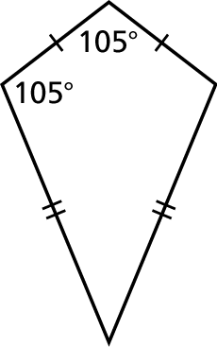62.)

63.) Using a protractor, draw a rhombus with two  angles.

Find the missing dimension. Use the scale factor 5 : 8.

64.) Model width: ?

Actual width: 20 ft

65.) A scale drawing of a painting is 12 inches long and 8 inches tall. The actual painting is 2 feet tall.

a. What is the scale of the drawing?

b. Find the perimeter and area of the painting in the scale drawing.

c. Find the actual perimeter and area of the painting.

**Chapter 8: Circles and Area**

Write and solve an equation to find the missing radius of the circle.

66.)  67.) 

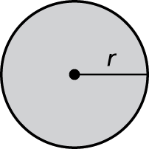

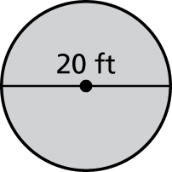Find the circumference and area of the circle. Use 3.14 or 

68.)

69.) The radius of a circle is 18 meters. What is the diameter?

Find the perimeter and area of the semicircle.

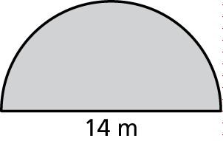

70.)

Find the area of each figure.

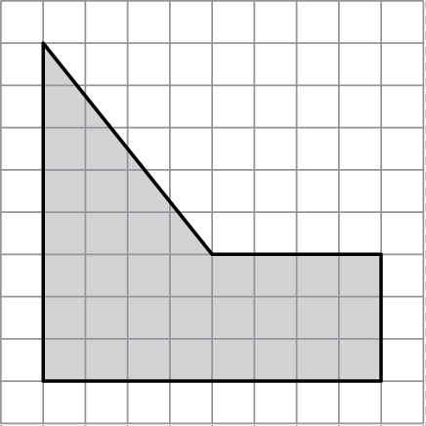

71.)

Find the perimeter and area of each figure.

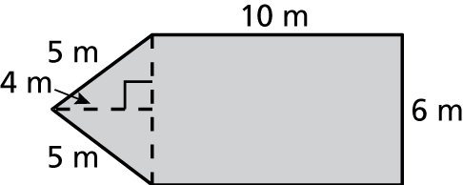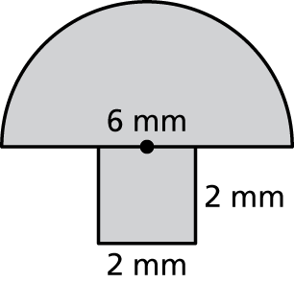 72.) 73.)

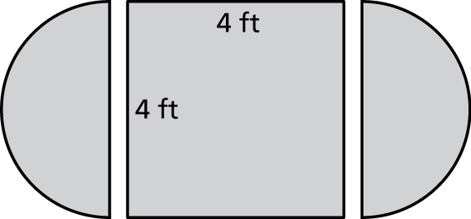 74.) A square table 4 feet on each side has two drop leaves, each a semicircle 4 feet in diameter.

Find the area and perimeter of the table *with and without* the drop leaves.

**Chapter 9: Surface Area and Volume**

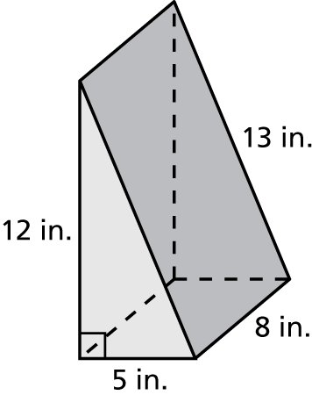Find the surface area and volume of the prism.

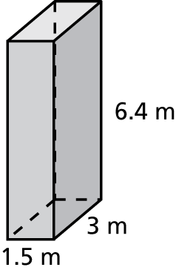

75.) 76.)

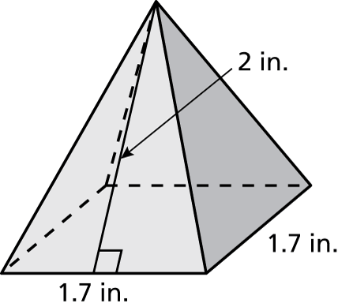Find the surface area of the regular pyramid. Round your answer to the nearest tenth.

77.)

Find the surface area of the cylinder. Round your answer to the nearest tenth.

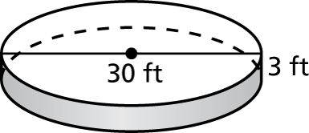

78.)

Find the volume of the regular pyramid.

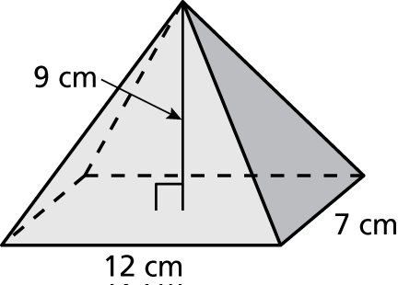

79.)

Find the surface area of the composite solid.

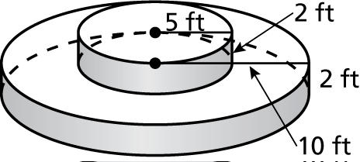

80.)

Find the volume of the composite solid below.

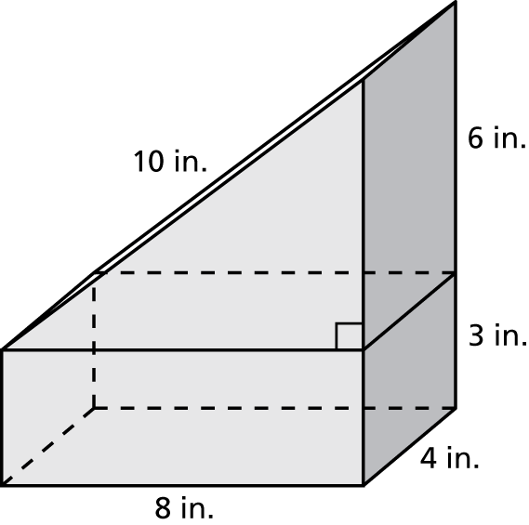 81.)

82.) What happens to the volume of a rectangular prism when the length and width are doubled and the height is tripled?

Identify the intersection of the plane and the solid.

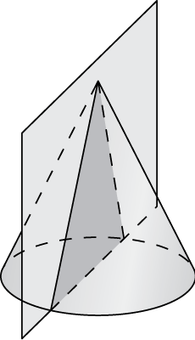

83.)

**Chapter 10: Probability and Statistics**

84.) A bag contains 8 red marbles, 3 green marbles, 2 white marbles and 1 yellow marble. What is the probability of selecting a white marble?

* 1. 
  2. 
  3. 2
  4. 

85.) A die is rolled 5 times and a “2” is rolled each time. What is the experimental probability for rolling a 3?

1. 
2. 
3. 0
4. 1

86.) Mark bowls a strike 32% of the time. If he rolls the bowling ball twenty times, how many strikes should he expect to make?

a. 32 b. 20 c. 6 d. 5

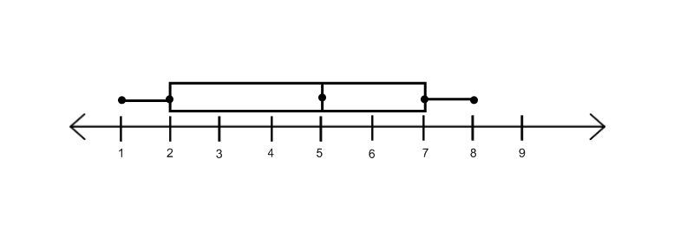

87.) The party registration of the voters in Jonesville is shown in the table below.

|  |  |
| --- | --- |
| **Registered Voters in**  **Jonesville** | |
| **Party Registration** | **Number of Voters**  **Registered** |
| Democrat | 6,000 |
| Republican | 5,300 |
| Independent | 3,700 |

If one of the registered Jonesville voters is selected at random, what is the probability that the person selected is ***not* a Democrat?**

1. 0.333
2. 0.400
3. 0.600
4. 0.667

88.) Peter wants to compare the data he collected about the varsity and junior varsity basketball teams. He recorded the number of points each team earned at every home and away game. Use the following dot plot to answer the questions below.

**Points Earned per Game – Varsity Team**

x x

x x x x x

x x x x x

x x x x x x x x

20 21 22 23 24 25 26 27 28 29 30

1. What is the **mean** number of points earned per game for the Varsity Team?
2. What is the **mean absolute deviation** of the Varsity Team?

89) A survey of 500 randomly selected people who commute to Manhattan for work showed that 187 of them used public transportation. An estimated 108,000 people commute to Manhattan every workday*.*

How many commuters use public transportation?

**Chapter 11: Transformations**

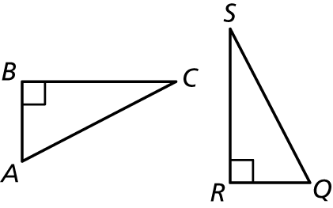Triangles *ABC* and *QRS* are congruent.

90.) Which angle of *ABC* corresponds to 

91.) Which side of *ABC* corresponds to side *SQ*?

Tell whether the shaded figure is a *translation, reflection, rotation,* or *dilation* of the nonshaded figure.

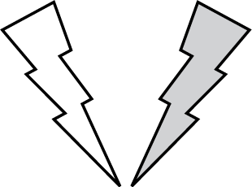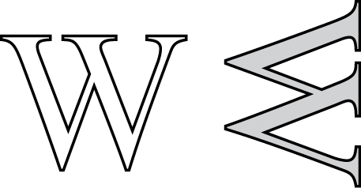

92.) 93.)

94.) The vertices of a rectangle are  and 

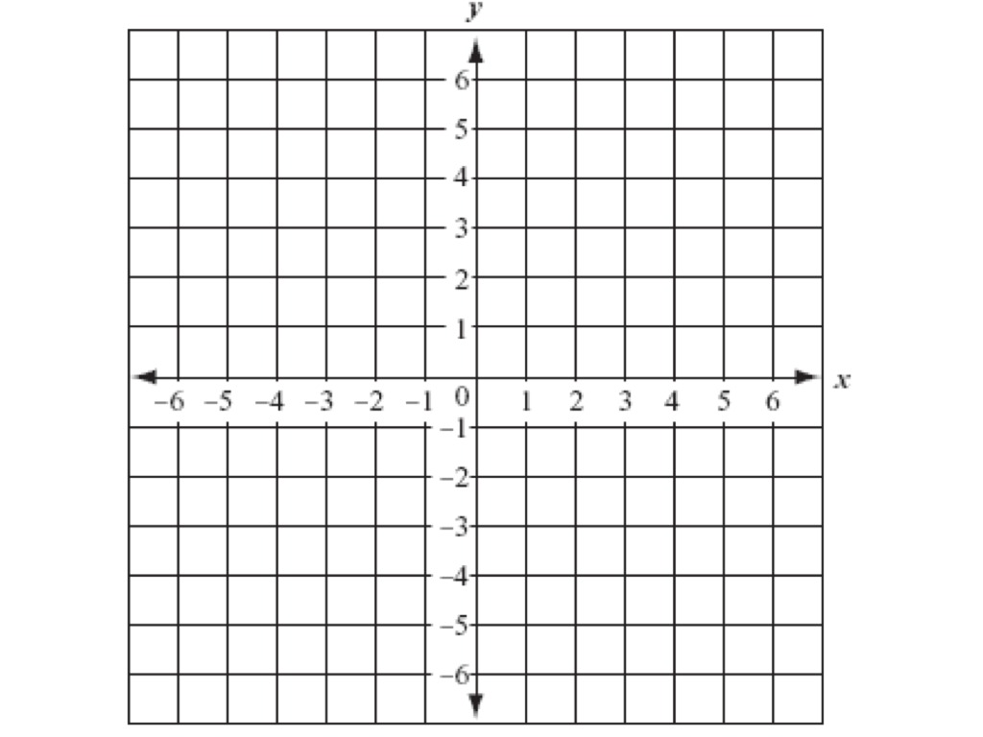 *Reflect the rectangle in the y-axis*, and then *rotate the rectangle 180° about the origin*. What are the coordinates of the image?

95.) The vertices of a triangle are **and   
*Dilate* the triangle with respect to the origin using a *scale factor of 2*. Then *translate* the image 5 units right and 1 unit down.   
What are the coordinates of the image?



*Rotate the triangle  about the origin*. Find the coordinates of the image.

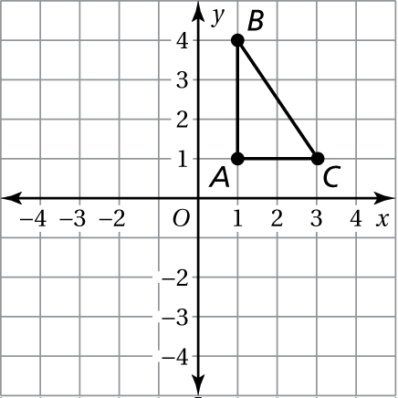

96 Tell whether the two figures are similar. Explain your reasoning..)

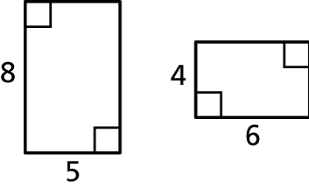

97.) The two figures are similar. Find the ratios (small to large) of the perimeters and of the areas.

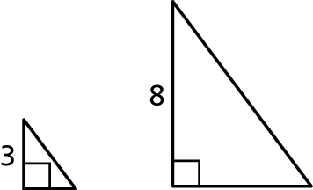

98.) The scale on a map is 1 in. : 50 mi. The actual distance between two cities is 350 miles. What is the distance between the cities on the map?

99.) The vertices of a triangle are 

Rotate the triangle as described. Find the coordinates of the image.

 **a. )**  counterclockwise about vertex A

b.)  about vertex *C*

**Chapter 12: Angles and Triangles**

Tell whether the angles are adjacent or vertical. Then find the value of x.

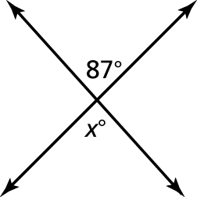100.)

Find the value of *x*. Then classify the triangle.

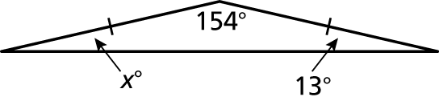 101.)

Classify the quadrilateral.

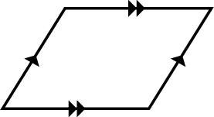102.)

Find the missing dimension. Use the scale factor 1 : 8.

103.) Model Length: 6cm

Actual length:?

Find the value of *x*.

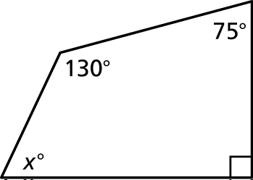104.)

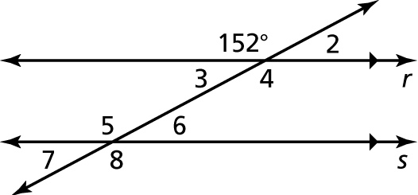Use the figure to find the measure of the angle. Explain your reasoning using angle relationship.

105.)









Find the measures of the interior angles.

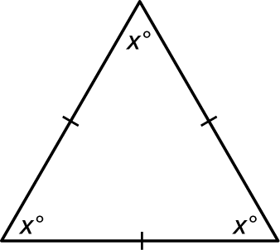

106.)

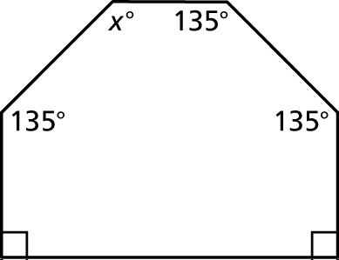

107.)

Find the measure of the exterior angle.

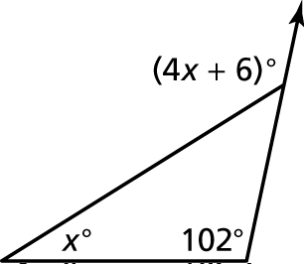108.)

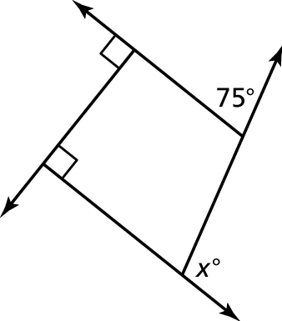

109.)

110.) Can a hexagon have angles that measure   
and Explain below.

111.) Is the shape below concave or convex

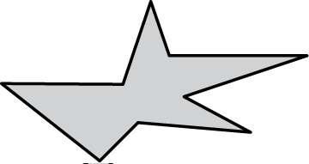

**Chapter 13: Graphing and Writing linear Equations**

Graph the linear equation. Use the x-coordinates: -3, 0, 3. Be sure to draw the table next to each graph.

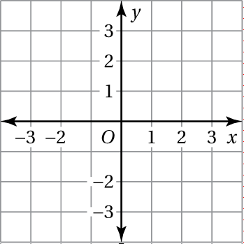

112.) 



113.) x= 2

Find the slope of the line.

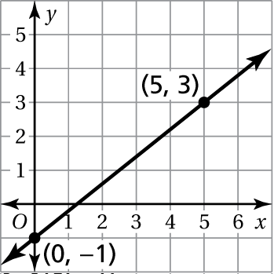114.)

Find the slope given the points.

115.) (4, 6) and (2, -10)

116.) (, -2) and (

Use an equation to find the value of k so that the line that passes through the given points has the given slope.

117.) (4, -4), (k , -1) ; m =

118.) **.** y – 2x = 1

a.) Solve the equations for y.

b.) Create a table using -3, 0, and 3 for the x-coordinates. *You do not need to graph*

Find the *x*- and *y*-intercepts of the graph of the equation.

119.) 

Write an equation of the line in slope-intercept form.

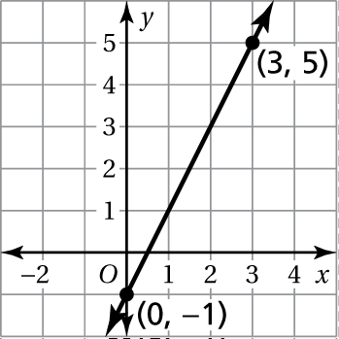

120.)

**Chapter 15: Volume and Similar Solids**

Find the volume of the solid. Round your answer to the nearest tenth.

121-123.)

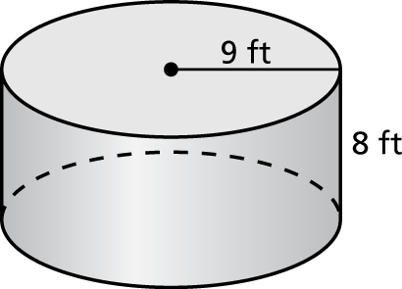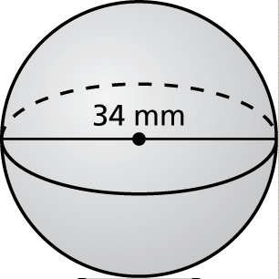

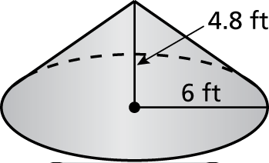

Find the missing dimension of the solid. Round your answer to the nearest tenth.

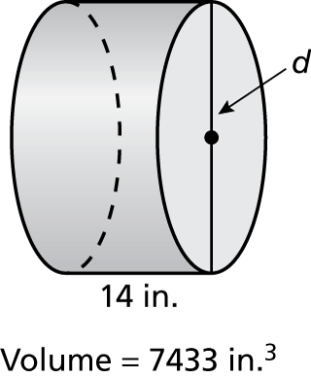

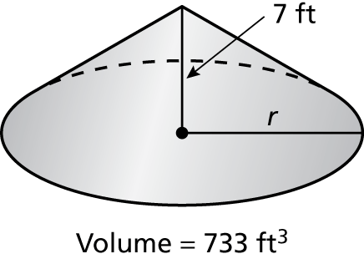124.) 125.)

Find the radius of the sphere with the given volume.

126.) 

127.) What happens to the volume of a rectangular prism when the length and width are doubled and the height is tripled?

Find the volume of the composite solid. Round your answer to the nearest tenth.

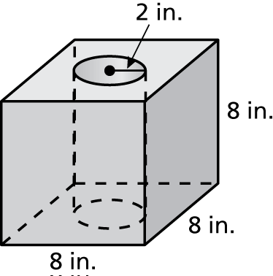

128.)

Determine whether the solids are similar. You must show and explain your work/answer.

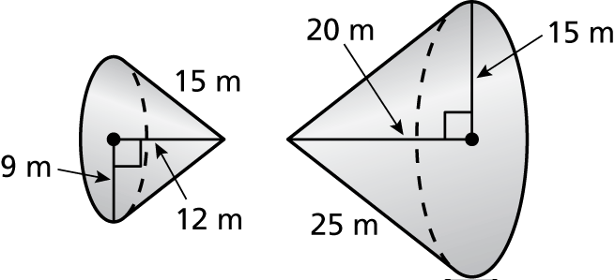

129.)

The solids are similar. Find the surface area *S* or the volume *V* of the smaller solid.

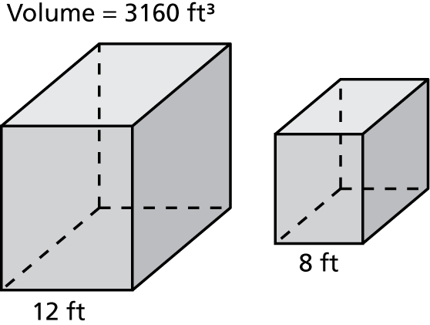

130.)

131.) A juice can is in the shape of a cylinder with a diameter of 4 inches. It has a volume of 125 cubic inches. What is the height of the can? Round your answer to the nearest whole number.