7.4: Quadrilaterals

Classify the quadrilateral.

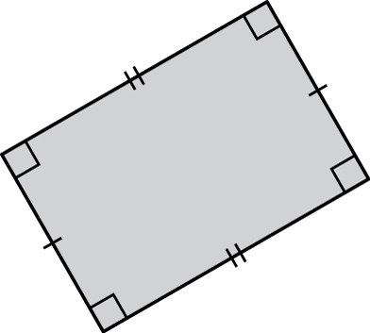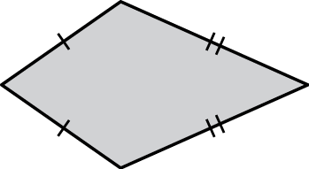 1. kite : 2 pairs of adjacent sides are 2. **Rectangle:** **2 pairs of parallel sides congruent and 4 right angles. Opposite side C**

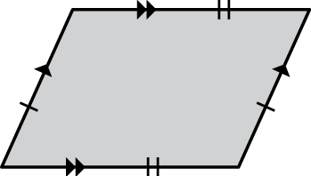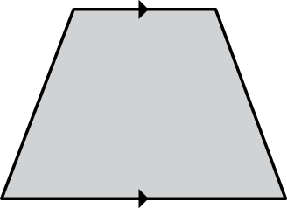 3. Trapezoid: 1 pair of opposite sides parallel 4. Parallelogram : opposite sides parallel **and congruent**

ALL angles in a quadrilateral add up to 360o

Find the value of *x*.

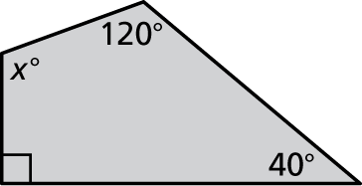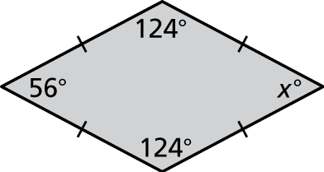 5. Rhombus 6. Quadrilateral

x = 56o

6. 120 + 40 +90 +x = 360; x = 110o

Copy and complete using *always*, *sometimes*, or *never*.

7. A square is  a rhombus.  **ALWAYS**

8. A parallelogram is  a rectangle. SOMETIMES

they both have 2 pairs of parallel sides, but a rectangle has 4 right angles, but a parallelogram does not.

9. A kite is  a square. NEVER

a kite has 2 pairs of congruent sides, but a square has 4 congruent sides

10. A trapezoid is  a square. NEVER

a trapezoid has 1 pair of parallelogram, but a square has 2

11. Draw the following trapezoids. If it is not possible, explain why.

a. a trapezoid with one right angle

not possible

b. a trapezoid with two right angles

yes

c. a trapezoid with three right angles

no, because 3 right angles would force you to draw a square. **Or 4 right angles.**

d. a trapezoid with four right angles

no, because it would be a square

12.3: Angles of Polygons

Convex:

Concave:

Regular Polygon:

Use triangles to find the sum of the interior angle measures of the polygon.

1. 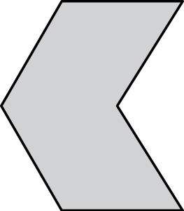 2. 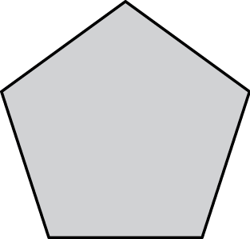

Find the sum of the interior angle measures of the polygon.

3. 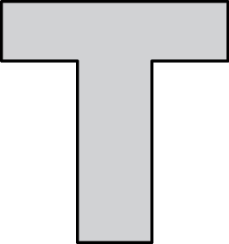 4. 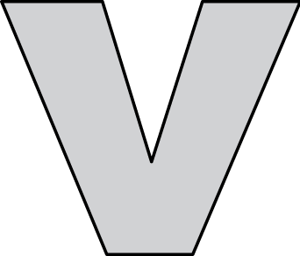

5. Can an octagon have interior angles that measure   
 Explain.

Find the measures of the interior angles.

6. 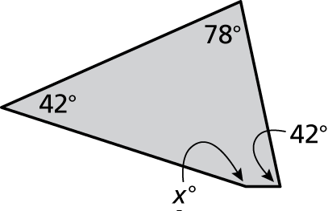 7. 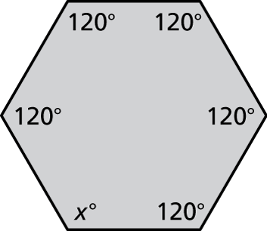

8. A stop sign is in the shape of a regular octagon. What is the measure of each interior angle?

Find the measures of the exterior angles of the polygon.

9. 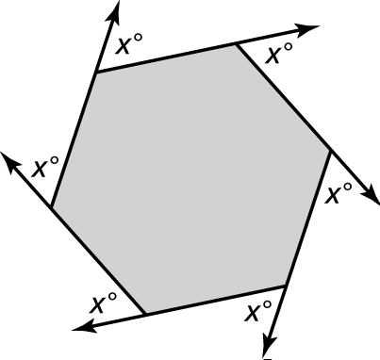 10. 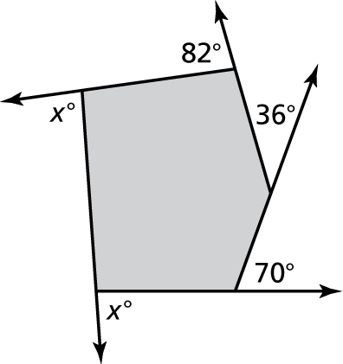

12.4: Using Similar Triangles

Tell whether the triangles are similar. Explain.

1. 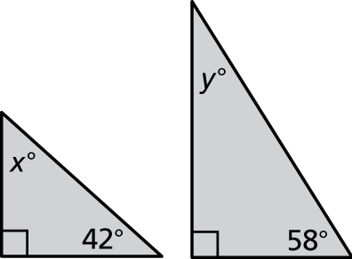 2. 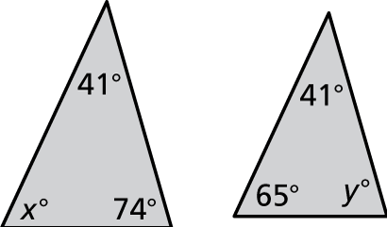

3. The triangles are sim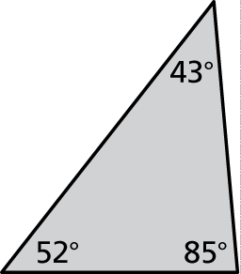ilar. Find the value of *x*.

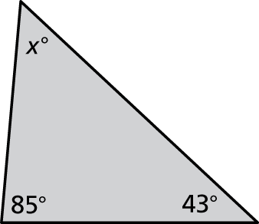

4. You can use indirect measurement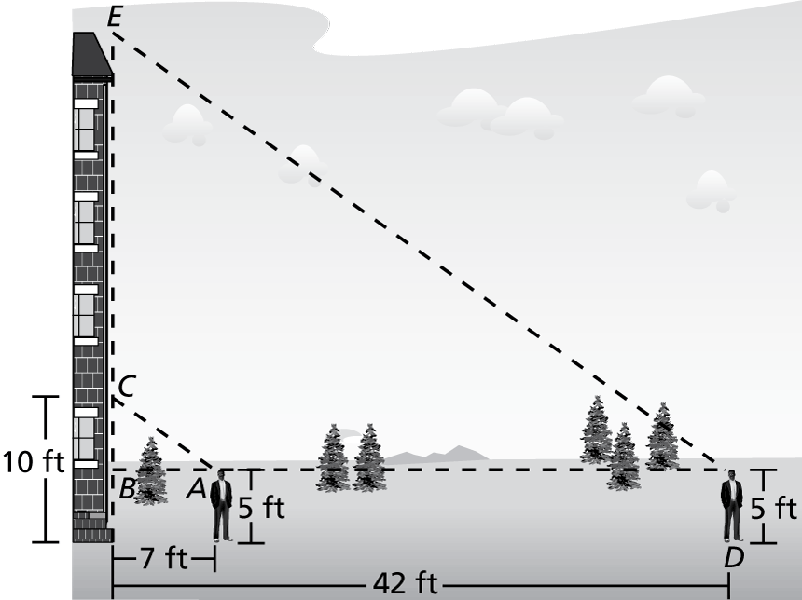  
to estimate the height of a building.   
First measure your distance from   
the base of the building and the   
distance from the ground to a point   
on the building that you are looking   
at. Maintaining the same angle of   
sight, move back until the top of   
the building is in your line of sight.

a. Explain why  and    
are similar.

b. What is the height of the building?

5. You and your friend are practicing for a rowing 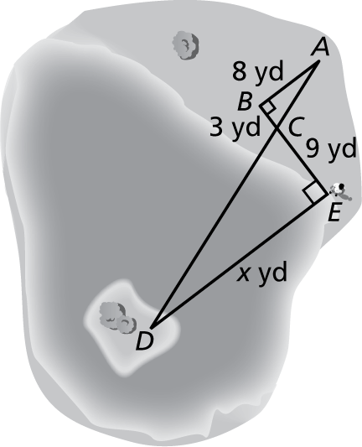  
competition and want to know how far it is to   
an island in the Indian River Lagoon. You take   
measurements on your side of the lagoon and   
make the drawing shown.

a. Explain why  and  are similar.

b. What is the distance to the island?