7.3: Triangles

Classifying Triangles Using Angles

Acute Triangle

Obtuse Triangle

Right Triangle

Equiangular

Classifying Triangles Using Sides

Scalene Triangle

Isosceles Triangle

Equilateral Triangle

Classify the triangle.

1. 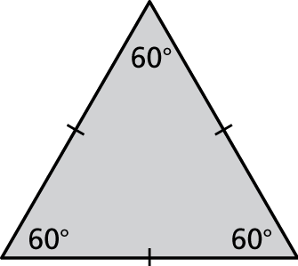 2. 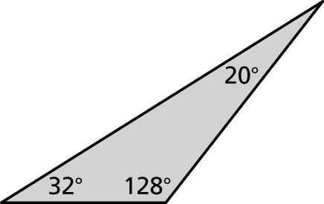

3. 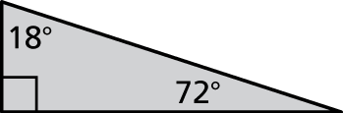 4. 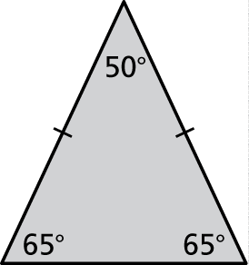

Draw a triangle with the given description.

5. a right triangle with two congruent sides

6. a scalene triangle with a 3-inch side and a 4-inch side that meet at   
a angle

7. Consider the three isosceles right triangles.

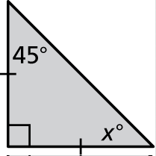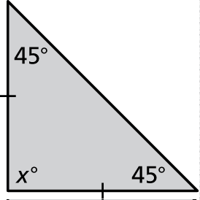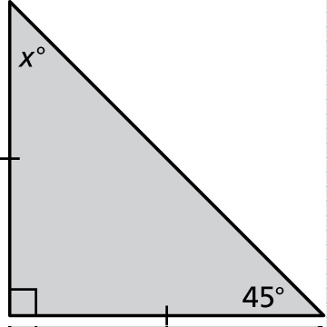

a. Find the value of *x* for each triangle.

b. What do you notice about the angle measures of each triangle?

c. Write a rule about the angle measures of an isosceles right triangle.

12.2: Angles of Triangles

Interior Angles of a Triangle:

The sum of the interior angle measures of a triangle is 180 degrees

Exterior Angle of a Triangle:

The measure of an exterior angle of a triangle is equal to the sum of the measures of the two nonadjacent interior angles

Find the measures of the interior angles.

1. 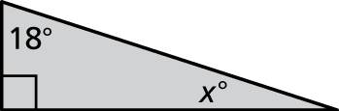 2. 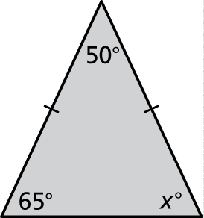

Find the measure of the exterior angle.

3. 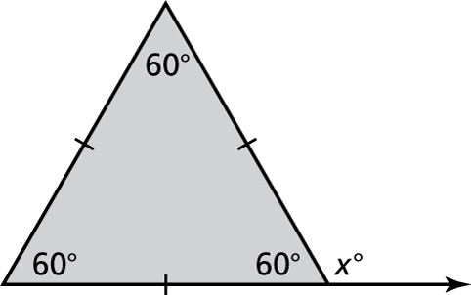 4. 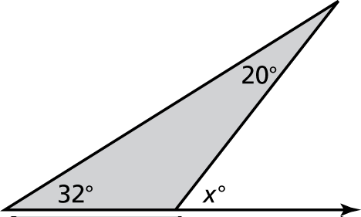

Tell whether a triangle can have the given angle measures. If not, change the first angle measure so that the angle measures form a triangle.

5.  6. 

7. Consider the three isosceles right triangles.

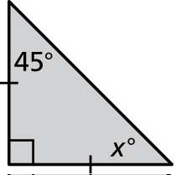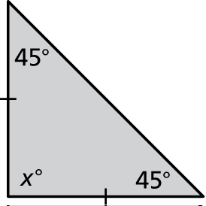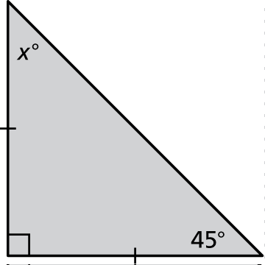

a. Find the value of *x* for each triangle.

b. What do you notice about the interior angle measures of each triangle?

c. Write a rule about the interior angle measures of an isosceles right triangle.