**11.1: Congruent Figures**

With a partner, discuss the questions below. Be sure to support your answers.

1. Is it possible for two triangles to have the same angle measures but not be congruent?

2. Is it possible for two triangles to have the same side lengths but not be congruent?

Congruent: 2 figures with the same size and shape

Corresponding Angles: Matching angles

Corresponding Sides: Matching sides

Tell whether the triangles are *congruent* or *not congruent*.

1. 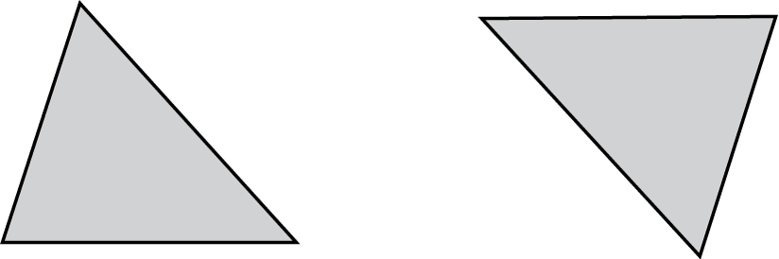

2. 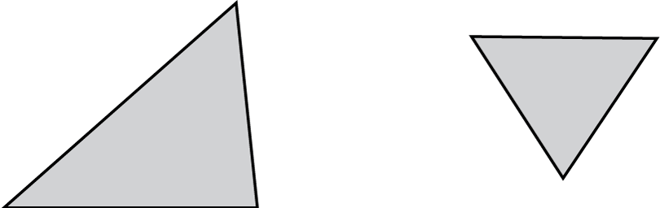

The figures are congruent. Name the corresponding angles and the corresponding sides.

3. 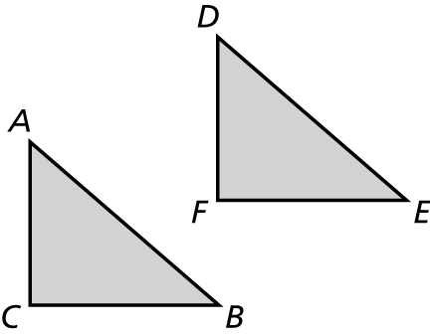 4. 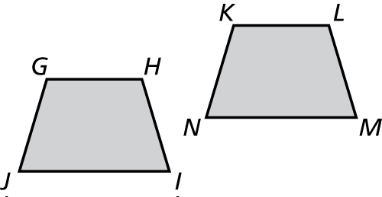

Tell whether the two figures are congruent. Explain your reasoning.

5. 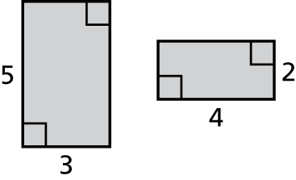 6. 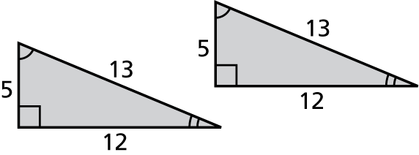

7. Describe and correct the error in telling whether the two figures are congruent.

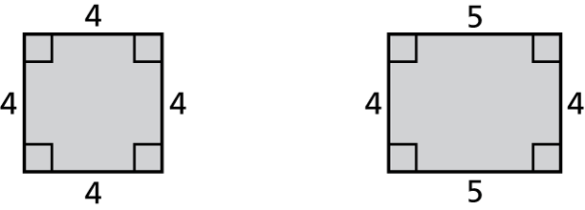

Both figures have four sides and corresponding angle measures are equal. So, they are congruent.

8. Can two polygons be congruent if one has a right angle and the other does not? Explain.