Name Date

Test A

Chapter

8

Find the number of faces, edges, and vertices of the solid.

Answers

1.

2.

3. See left.

4. See left.

5. See left.

6.

7.

8.

1. 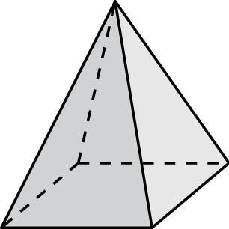 2. 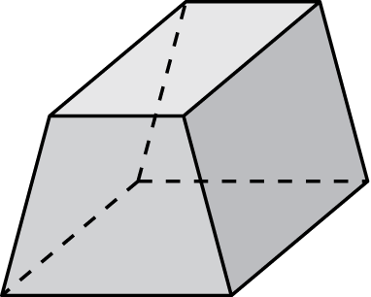

Draw the solid.

3. triangular pyramid 4. rectangular prism

5. Draw the front, side, and top views of the solid.

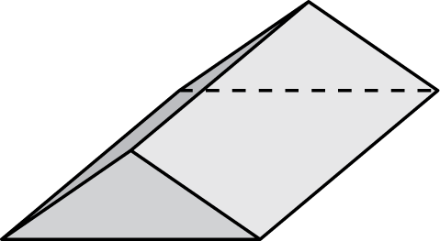

Find the surface area of the prism.

6. 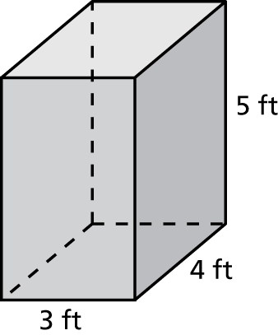 7. 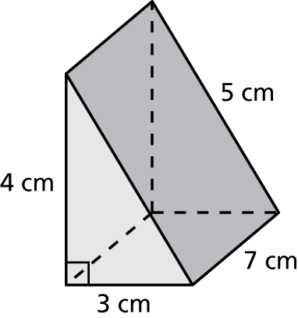

8. A piece for a board game is shaped like a triangular prism. The piece is 18 millimeters long. The base of the piece is an equilateral triangle with 10-millimeter sides and a height of 9 millimeters. Find the surface area of the game piece.

Name Date

Test A **(continued)**

Chapter

8

Find the surface area of the pyramid. The side lengths of the base   
are equal.

Answers

9.

10.

11.

12.

13.

14.

15.

16.

17.

9. 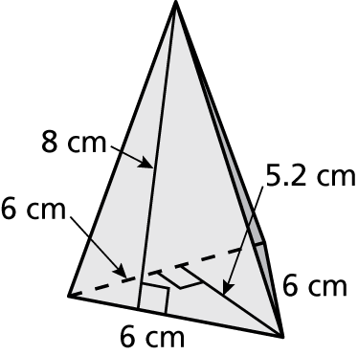 10. 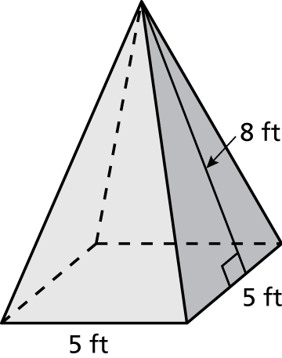

Find the volume of the prism.

11. 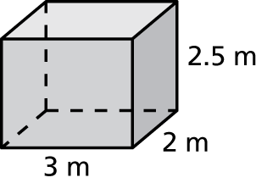 12. 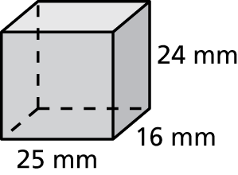

13. The rectangular prism has a volume 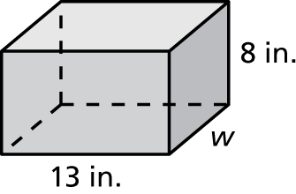  
of 936 cubic inches. Write and solve   
an equation to find the missing   
dimension of the prism.

14. A file folder box is in the shape of a rectangular prism with a length   
of 12 inches, a width of 9 inches, and a height of 10 inches. It is open   
at the top. Find the surface area of the file folder box.

15. A playhouse is in the shape of a square pyramid with a side length of   
6 feet and a slant height of 12 feet. The wood used to build the walls   
of the playhouse costs $3 per square foot. What is the cost of the wood for the walls of the playhouse?

16. To install the right size heating and cooling system, you must know how many cubic feet an office building contains. The building is   
120 feet wide, 20 feet high, and 48 feet long. Find the volume.

17. A raised gardening bed contains 32 cubic feet of dirt. The bed is   
6 feet wide and 8 feet long. How deep is the dirt?