**11.7: Dilations**

Draw the triangle with the given vertices. Multiply each coordinate of the vertices by 3 and then draw the new triangle. How are the two triangles related?

1. 

2. 

Dilation: a transformation in which a figure is made larger or smaller with respect to a point called the center of dilation.

Scale factor: the ratio of the side lengths of the image to the corresponding side lengths of the original figure

Draw the triangle with the given vertices. Multiply each coordinate of the vertices by 3 and then draw the new triangle. How are the two triangles related?

1.  2. 

Tell whether the dashed figure is a dilation of the solid figure.

3.  4. 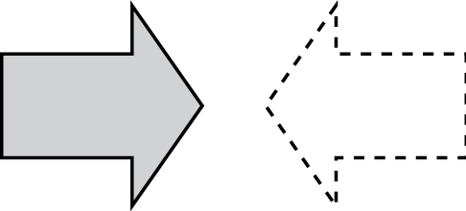

The vertices of a figure are given. Draw the figure and its image after a dilation with the given scale factor. Identify the type of dilation.

5. 

6. 

The dashed figure is a dilation of the solid figure. Identify the type of dilation and find the scale factor.

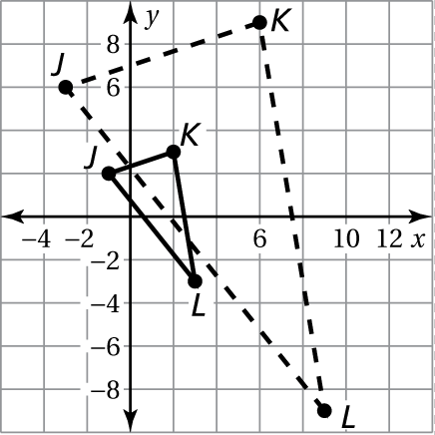

7. 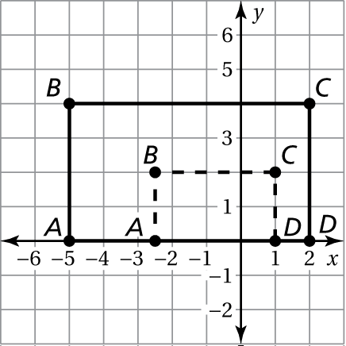 8.

9. A triangle is dilated using a scale factor of 4. The image is then dilated using a scale factor of 3. What scale factor could you use to dilate the original triangle to get the final image?

10. The vertices of a figure are and  Dilate with respect to the origin using a scale factor of 2 and then translate 4 units right and 3 units down. Find the coordinates of the figure after the transformations given.