Name Date

Test A

Chapter

10

1. Make a stem-and-leaf plot of the data.

|  |  |  |  |
| --- | --- | --- | --- |
| **Time (minutes)** | | | |
| 32 | 45 | 56 | 34 |
| 48 | 60 | 55 | 38 |
| 41 | 34 | 60 | 52 |

**Stem Leaf**

0 3

1 1 3 3

2 0 3 7 8

3 3

4 5 6 7 9

**Key: 1|5  15**

Answers

1. See left.

2.

3.

4.

5.

6.

7.

8.

9. See left.

10. a.

b.

c.

11. a.

b.

c.

The stem-and-leaf plot at the right shows   
the lengths (in inches) of some snakes.

2. How many data values are in the set?

3. Find the least value and the greatest value.

4. What is the median?

5. What is the range?

6. What is the interquartile range?

7. Which value occurs the most often?

8. Is the value 31 in the set? Explain.

9. Display the data in a histogram.

|  |  |
| --- | --- |
| **Books Read** | |
| **Books** | **Frequency** |
| 0–3 | 6 |
| 4–7 | 7 |
| 8–11 | 6 |
| 12–15 | 5 |

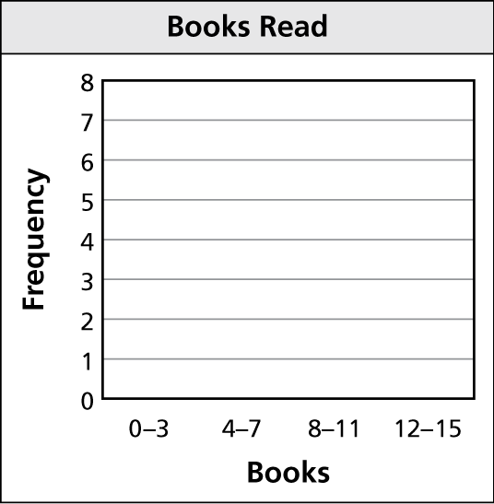

In Exercises 10 and 11, (a) describe the shape of each distribution,   
(b) choose the most appropriate measures to describe the center   
and variation, and (c) find the measures you chose.

10. 11.

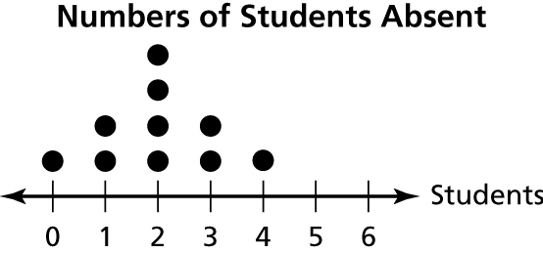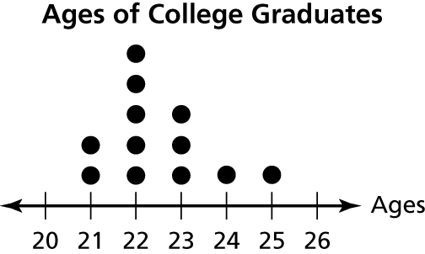

Name Date

Test A **(continued)**

Chapter

10

12. Make a box-and-whisker plot for the data.

Numbers of colors in a country’s flag: 3, 2, 2, 4, 4, 3, 6, 3, 5, 3, 4, 1

In Exercises 13–15, use the histogram   
that shows the numbers of songs   
downloaded per week by students in   
a class.

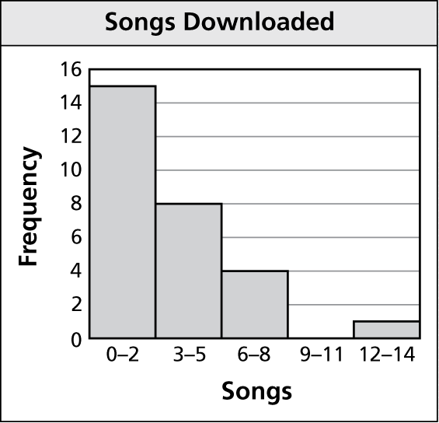

13. Which interval contains no   
data values?

14. How many students are in the class?

15. What percent of the students   
downloaded fewer than 6 songs?   
Round to the nearest tenth.

16. The data show the times (in minutes) spent fishing before getting a bite.

12, 25, 28, 20, 18, 16, 22, 30

a. Make a box-and-whisker plot of the data.

b. What fraction of the times are less than or equal to 17 minutes?

c. Find the range and interquartile range.

d. Identify the shape of the distribution. Explain.

Answers

12. See left.

13.

14.

15.

16. a. See left.

b.

c.

d.