Name Date

Answers

1.

2.

3.

4.

5.

6.

7.

8. See left.

9. See left.

10.

11.

12.

Test A

Chapter

14

Write the ratio as a fraction in simplest form.

1. 15 girls to 6 boys 2. 24 players : 3 teams

Find the unit rate.

3. 405 rotations in 5 minutes 4. 72 ounces for 12 servings

Tell whether the ratios form a proportion.

5.  6. 

7. The table shows the rates   
for sending text messages.   
Are the rates proportional?   
Explain.

|  |  |
| --- | --- |
| Messages | Cost |
| 50 | $6 |
| 75 | $9 |
| 100 | $12 |

Use a graph to tell whether *x* and *y* are in a proportional relationship.

8. 9.

|  |  |  |  |  |
| --- | --- | --- | --- | --- |
| *x* | 2 | 4 | 6 | 8 |
| *y* | 1 | 2 | 3 | 4 |

|  |  |  |  |  |
| --- | --- | --- | --- | --- |
| *x* | 3 | 6 | 9 | 12 |
| *y* | 7 | 13 | 19 | 25 |

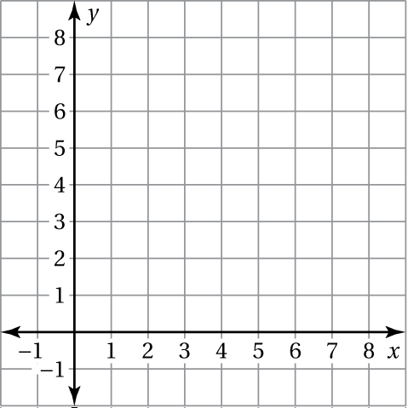 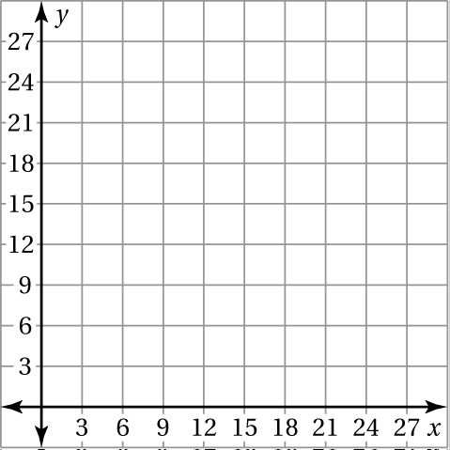

Use the table to write a proportion.

10. 11.

|  |  |  |
| --- | --- | --- |
|  | Saturday | Sunday |
| Minutes | *m* | 32 |
| Miles | 3 | 4 |

|  |  |  |
| --- | --- | --- |
|  | Serving  A | Serving  B |
| Servings | 2 | 5 |
| Calories | 310 | *c* |

12. You can buy 5 stickers for $3. Write a proportion that gives the   
cost *c* if you buy 12 stickers.

Name Date

Answers

13.

14.

15.

16.

17. See left.

18. See left.

19.

20.

21.

22. See left.

23.

24. a.

b.

c.

Test A **(continued)**

Chapter

14

Solve the proportion.

13.  14.  15.  16. 

Graph the line that passes through the two points. Then find the   
slope of the line.

17.  18. 

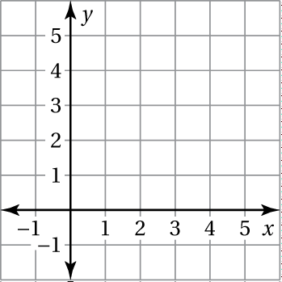 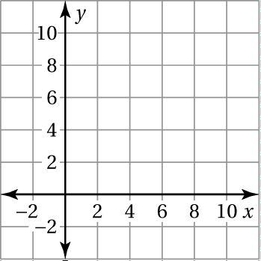

Tell whether *x* and *y* show direct variation. Explain your reasoning.

19. 20.  21. 

|  |  |  |  |  |
| --- | --- | --- | --- | --- |
| *x* | 1 | 2 | 3 | 4 |
| *y* | 4 | 8 | 12 | 16 |

22. Your baseball team has won 6 games and lost 4 games. If the team   
does not lose any more games, how many games must the team win   
to have a win : loss ratio of 2 : 1? Explain your answer.

23. It costs $145 for 10 people to attend a concert. How much does it cost   
a group of 8 people?

24. The graph shows the calories burned 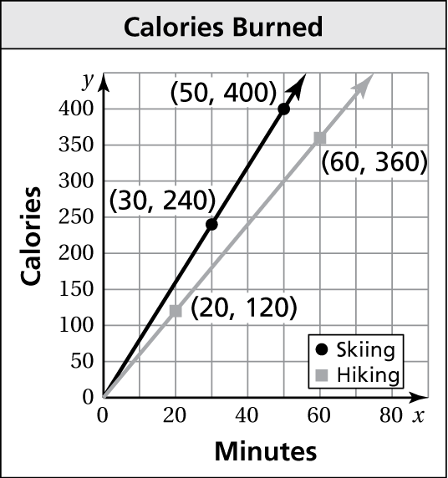  
for hiking and downhill skiing.

a. Find the slope of each line.

b. How many more calories do you   
burn per minute downhill skiing   
than hiking?

c. How many calories would you   
burn if you went downhill skiing   
for 80 minutes?