13.7: Writing Equations in Point-Slope Form

\*The line passes through the point (, and the slope of the line is *m*

Use the point-slope form to write an equation of the line with the given slope that passes through the given point.

1.  2. 

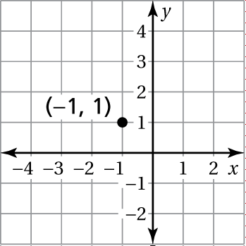 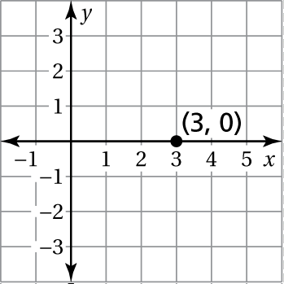

Write in point-slope form an equation of the line that passes through   
the given point and has the given slope.

3.  4. 

5.  6. 

Write in slope-intercept form an equation of the line that passes through   
the given points.

7.  8. 

9.  10. 

11. After a laptop is purchased, its value decreases by $150 each year.   
After 2 years, the laptop is worth $600.

a. Write an equation that represents the value *V* (in dollars) of the   
laptop *x* years after it is purchased.

b. What was the original value of the laptop?

c. What is the value of the laptop 5 years after it is purchased?