**Mid Term Review**

**Intro to Pre-Algebra: Unit 1-Unit 6**

**Unit 1: Integers**

**Unit 2: Rational Numbers**

**Unit 3: Expressions and Equations**

**Unit 4: Inequalities**

**Unit 5: Ratios and Proportions**

**Unit 6: Percents (If we finish the unit)**

**Unit 1:**

Find the absolute value.

1.  2.  3. 

Complete the statement using 

4.    5.2   6. 5  

Order the values from least to greatest.

7.  8. 

9. The temperature in St. Louis, Missouri, is 31°F. The temperature   
in Duluth, Minnesota, is –29°F. Is the temperature in St. Louis or   
Duluth closer to 0°F?

Evaluate the expression.

10.  11. 

12.  13. 

**Multiply.**

14.  15. 

**Divide, if possible.**

16.  17. 

18. The water level is 3 feet below your dock. The tide goes out, and   
the water level lowers 1 foot. A storm surge comes in, and the water level rises 2 feet. Write an integer to indicate the new water level.

19. Two integers, *n* and *p*, have a product of –24. What is the largest possible sum of *n* and *p*? Explain how you found your answer.

Evaluate the expression.

20.  21. 

Find the mean of the integers.

22. 

**Unit 2:**

1. Order the numbers from least to greatest.



Complete the statement using 

2.  3. 

Find the distance between the two numbers on the number line.

4. **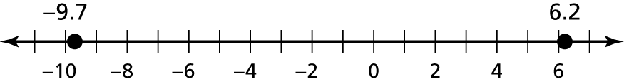**

5. **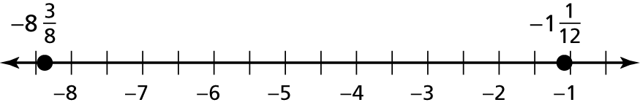**

Add or subtract. Write fractions in simplest form.

6.  7. 

8.  9. 

Evaluate the expression when 

10.  11. 

12.  13. 

14. You spendhours hiking and an additionalhour to rest.

a. How much time did you spend hiking and resting?

b. How much more time did you spend hiking than resting?

15. Find a repeating decimal between 

Evaluate.

16.  17. 

18.  19. 

20.  21. 

22. The table shows the changes in rainfall (in inches) from the monthly average of four months. What is the mean change?

|  |  |  |  |  |
| --- | --- | --- | --- | --- |
| Month | May | June | July | August |
| Change (inches) | 1.05 | –0.58 | –2.12 | –2.67 |

23. A recipe calls forcups of sugar. You havecups of sugar.   
Do you have enough sugar? If not, how much more sugar is needed? Explain your answer.

24. A 10.5-gallon aquarium isfull. How many more gallons of water does it take to fill the aquarium?

25. How many 0.45-ounce packages of cinnamon can be made with   
3.15 ounces of cinnamon?

**Unit 3:**

Identify the terms, like terms, coefficients and constants in the expression.

1. 

2. 

3. 

Find the sum or difference.

4.  5. 

6.  7. 

8. (-2g – 9) – (g +11) 9.

Factor out the coefficient of the variable.(reverse distributive property)

10.  11. 

12. Write an expression that represents the perimeter of the polygon.

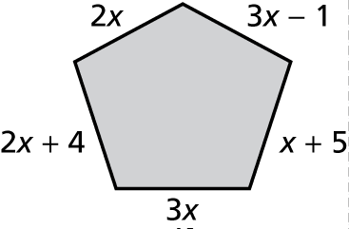

13. Write a formula for the area of the shaded region in terms of *x*.

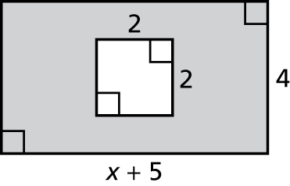

14. The expression  represents the perimeter (in meters) of   
the triangle. Write an expression in simplest form that represents   
the measure of the third side.

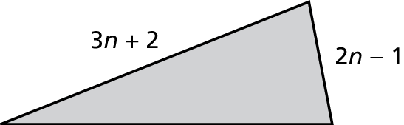

Solve the equation. Check your solution.

15.  16. **

17.  18. 

Find the value(s) of *x*.

19.  20. 

21. 22.

Write the word sentence as an equation. Then solve.

23. The sum of a number *a* and negative 12 is 6.

24. 45 equals the quotient of a number *n* and 3.

25. The difference of 2.1 and twice a number *p* is negative 4.7.

26. One-half the sum of a number *z* and 

27. You drink *g* 8-ounce glasses of water plus a 20-ounce bottle   
of water. You drank 76 ounces of water today. Write and solve   
an equation to determine the number of glasses of water you   
drank.

28. Your friend has owned a dog for 9 years. This is one year less   
than twice as long as he has owned a cat. How long has your   
friend owned a cat?

29. Litter cleanup volunteers form 4 groups containing *v* volunteers   
each. Then 10 more volunteers show up. The volunteers regroup   
into 5 groups each containing 6 people. How many volunteers   
were in each original group?

**Unit 4:**

Write the word sentence as an inequality.

1. A number *x* is less than 

1. A number *n* is no more than 8.
2. A number *m* minus 3 is more than 

4. Sixteen times a number *j* is no less than 

1. Twice a number *q* minus 1 is less than 5.

6.A number *a* divided by 2 is no more than 6.

7. To pass the test you must score at least 60 on the test.

8. The maximum cost is $35.

Tell whether the given value is a solution of the inequality.

9.  10. 

11. A video game gives you 100 seconds to complete the level and move   
to the next. You are halfway through the level after 55 seconds.

a. Write and solve an inequality to find out how much time you have left to complete the level.

b. You will receive a time bonus if you finish in 70 seconds or less. Write and solve an inequality to find how much time you have left to earn a time bonus.

c. You finish the game in another 32 seconds. Do you earn a time bonus? Do you move to the next level? Explain.

12. An isosceles triangle has a base of 5 centimeters and legs *x* centimeters   
long. The perimeter is no more than 30 centimeters. Write and solve an   
inequality to find the possible values of *x*.

Solve the inequality.

13.  14.  15. 

16.  17.  18. 

Solve the inequality. Graph the solution.

TA: C:\replacearts\Red Assessment Book\Red Chapter 4 AB\Arts\PNGs\mscc7_ab_0400_08.png 19. 

TA: C:\replacearts\Red Assessment Book\Red Chapter 4 AB\Arts\PNGs\mscc7_ab_0400_08.png 20. 

TA: C:\replacearts\Red Assessment Book\Red Chapter 4 AB\Arts\PNGs\mscc7_ab_0400_08.png 21. 

TA: C:\replacearts\Red Assessment Book\Red Chapter 4 AB\Arts\PNGs\mscc7_ab_0400_08.png22. 

23. A music teacher budgets $150 for new books. The minimum cost of a new book is $12. How many books can she buy? Is this a minimum or a maximum amount? Explain.

24. The perimeter of the rectangle is at 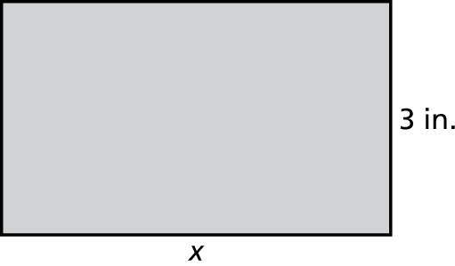  
least 12 inches. The area is no more   
than 27 inches. Write and solve an   
inequality for each condition. Give   
two possible values for *x*.

**Unit 5:**

Write the ratio as a fraction in simplest form.

1. 48 worksheets : 12 students 2. 35 frogs to 21 lizards

Find the unit rate.

3. 240 kilometers in 2.5 hours 4. $15 for 4 quarts

Tell whether the ratios form a proportion.

5.  6. 

Tell whether *x* and *y* are proportional. If yes, find k.

7. 8.

|  |  |  |  |  |
| --- | --- | --- | --- | --- |
| *x* | 2 | 3 | 4 | 5 |
| *y* | 5 | 7.5 | 10 | 12.5 |

|  |  |  |  |  |
| --- | --- | --- | --- | --- |
| *x* | 5 | 10 | 15 | 20 |
| *y* | 1 | 3 | 5 | 7 |

9. The table shows the different   
rates to ship books through the   
mail. Are the rates proportional?   
What is the unit rate? Explain.

|  |  |
| --- | --- |
| Pounds | Cost |
| 4 | $3.55 |
| 6 | $4.33 |
| 8 | $5.11 |

Use the table to write a proportion.

|  |  |  |
| --- | --- | --- |
|  | Tank  A | Tank  B |
| Fish | 6 | *f* |
| Gallons | 10 | 55 |

10. 11.

|  |  |  |
| --- | --- | --- |
|  | 512 MB  MP3  Player | 2 GB  MP3  Player |
| Hours | 17 | 68 |
| Songs | *s* | 1000 |

12. You can buy 5 pounds of grapes for $9.95. Write a proportion that gives the cost *c* if you buy 4 pounds of grapes.

Solve the proportion.

13.  14.  15. 

16.  17.  18. 

Graph the line that passes through the two points. Then find the slope of the line.

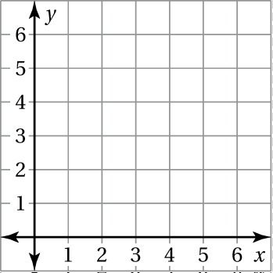 19.  20. 

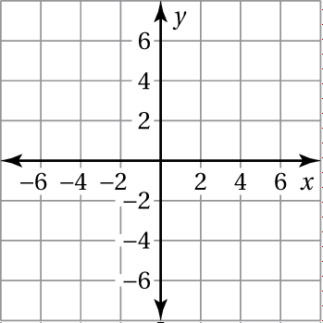

Tell whether *x* and *y* show direct variation. Explain your reasoning.

21.  22. 

The variables *x* and *y* vary directly. Use the values to find the constant of proportionality and write an equation that relates *x* and *y*.

23.  24. 

25. Write a direct variation equation that relates *x* miles to *y* kilometers.

26. As part of a pancake recipe, you mix cup of milk for every 1 cup of flour to make 7 cups of batter. How much of each ingredient do you use?

27. You earn $102 for doing 12 hours of yard work. Your friend earns $120 working at a store for 15 hours.

**a.** Who has a greater hourly rate of pay?

**b.** What would you earn if you did 15 hours of yard work and were paid at your same hourly rate?

28. A line has a slope of 5. It passes through the points What is the value of *y*? Explain how you found your answer.

29. There are 25 computers in a math lab. There are 6 activity booklets for every 2 computers in the math lab. How many activity booklets are in the math lab?

**Unit 6:**

Write the percent as a decimal.

1. 0.05% 2. 128%

3. A teacher weights the final grade as follows:  for homework,   
25% for a project, 0.4 for quizzes, and 15% for the final exam.   
Order these categories from least weighted to greatest weighted.

In Exercises 4–6, use the table.

|  |  |  |  |
| --- | --- | --- | --- |
| Question | 6th-graders | 7th-graders | 8th-graders |
| Participate in sports? |  | 18% | 0.22 |
| Participate in other school activities? | 33% | 0.45 |  |

4. Which category in the table shows the least portion?

5. Which is greater, the percent of 7th-graders or 8th-graders participating in other school activities?

1. Your friend says that at least twice as many 7th-graders participate in other activities as play sports. Is this true? Explain.

Write and solve a proportion to answer the question.

7. What number is 45% of 60? 8. 48 is what percent of 160?

Write and solve an equation to answer the question.

9. 8 is 0.5% of what number? 10. What percent of 130 is 182?

Identify the percent of change as an *increase* or *decrease*. Then   
find the percent of change. Round to the nearest tenth of a percent,   
if necessary.

11.  to  12. $18.75 to $18.60

Find the new amount.

13. 2000 miles increased by 33% 14. 140 degrees decreased by 65%

**Find the original price, discount, sale price, or selling price.**

15. Original price: $0.75 16. Original price: ?   
Discount: ? Discount: 30%  
Sale price: $0.15 Sale price: $206.50

17. Original price: $24.50 18. Cost to store: $145  
Discount: 18% Markup: 150%   
Sale price: ? Selling price: ?

An account earns annual simple interest. Find the interest earned, principal, interest rate, or time.

19. Interest earned: ? 20. Interest earned: $7.50  
Principal: $800 Principal: ?   
Interest rate: 6.5% Interest rate: 12%  
Time: 2 years Time: 3 months

21. Interest earned: $235.50 22. Interest earned: $837  
Principal: $7850 Principal: $3100  
Interest rate: 2% Interest rate: ?   
Time: ? Time: 6 years

An account earns annual simple interest. Find the balance of   
the account.

23. $1400 at 1.25% for 3 years 24. $5000 at 6% for 9 months

25. The gas tank of your car is 40% full. There are 8 gallons of gas in   
the tank. What is the capacity of the gas tank?

26. You purchased a stock on Monday for $24 per share.

a. On Tuesday, the stock price was $36 per share. What was the percent increase?

b. On Wednesday, the stock price had a percent decrease of 50%.   
What was the new stock price?

27. The cost of manufacturing a printer is $35. The manufacturer has a markup of 15% when selling to a retailer. The retailer has a markup   
of 35%. What is the selling price of the printer?

28. How long will it take $500 to double at a simple interest rate of 5%? Explain how you found your answer.