13.3: Graphing Proportional Relationships

*When two quantities x and y are proportional, the relationship can be represented by the direct variation equation y = mx, where m is the constant of proportionality, the slope, and the unit rate.

Tell whether *x* and *y* are in a proportional relationship. Explain your reasoning.

If so, write an equation that represents the relationship.

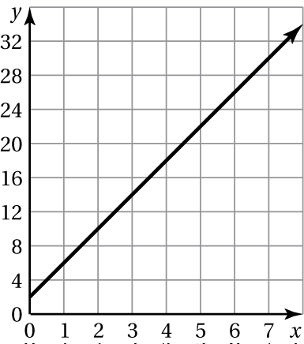

1. 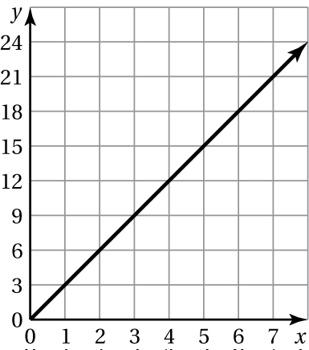 2.

|  |  |  |  |  |
| --- | --- | --- | --- | --- |
| *x* | 4 | 8 | 12 | 16 |
| *y* | 1 | 2 | 3 | 4 |

3. 4.

|  |  |  |  |  |
| --- | --- | --- | --- | --- |
| *x* | 5 | 10 | 15 | 20 |
| *y* | 1 | 3 | 5 | 7 |

5. The distance your friend travels *y* (in miles) running *x* hours is represented by the equation 

a. Graph the equation and interpret the slope.

b. How many minutes does it take for your friend to run one mile?

6. At a concession stand, hamburgers are selling at a rate of 160 hamburgers per hour. The table shows the rate at which wraps are selling.

|  |  |  |  |  |
| --- | --- | --- | --- | --- |
| Minutes | 1 | 2 | 3 | 4 |
| Wraps Sold | 2.5 | 5 | 7.5 | 10 |

1. Do hamburgers or wraps sell faster? Explain.

b. Graph equations that represent the growth rates of hamburgers sold   
and wraps sold in the same coordinate plane. Compare the steepness   
of the graphs. What does this mean in the context of the problem?