15.4: Surface Areas and Volumes of Similar Solids

Similar Solids-

Are solids that have the same shape and proportional corresponding dimensions

Determine whether the solids are similar.

1. 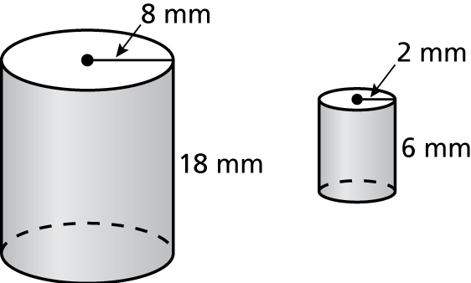 2. 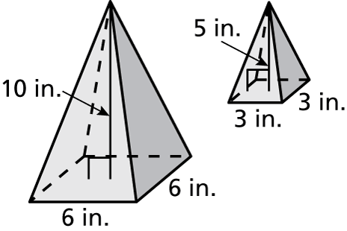

The solids are similar. Find the missing dimension(s).

3. 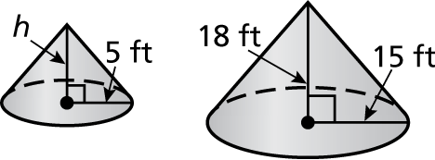 4. 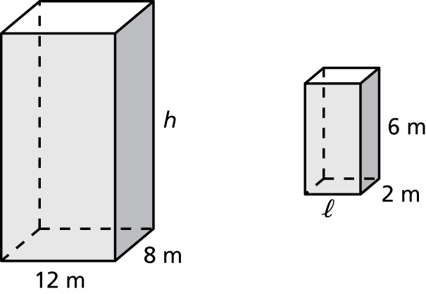

The solids are similar. Find the surface area *S* or the volume *V* of the larger solid. Round your answer to the nearest tenth.

5.  6. 

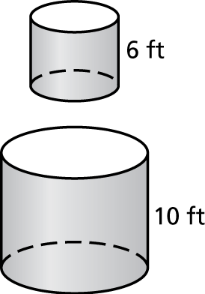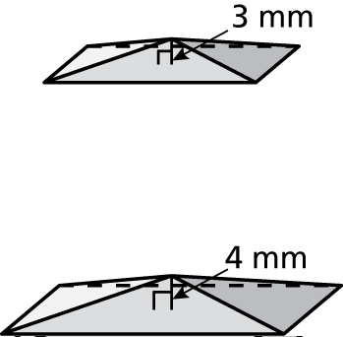

7. The ratio of the corresponding linear measures of two similar cans of cat food is 4 : 3.

a. The larger can has a surface area of 100 square inches. Find the surface area of the smaller can. Round your answer to the nearest tenth.

b. The larger can has a volume of 150 cubic inches. Find the volume of   
the smaller can. Round your answer to the nearest tenth.