Name Date

Answers

1.

2.

3.

4.

5.

6.

7.

8.

9.

10.

11.

12.

Test A

Chapter

13

Identify the terms and like terms in the expression.

1. 

2. 

3. 

Find the sum or difference.

4.  5. 

6.  7. 

Factor out the coefficient of the variable.

8.  9. 

10. Write an expression in simplest form that represents the perimeter   
of the polygon.

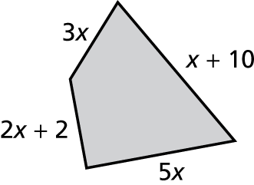

11. Write an expression in simplest form that represents the area of the picture frame.

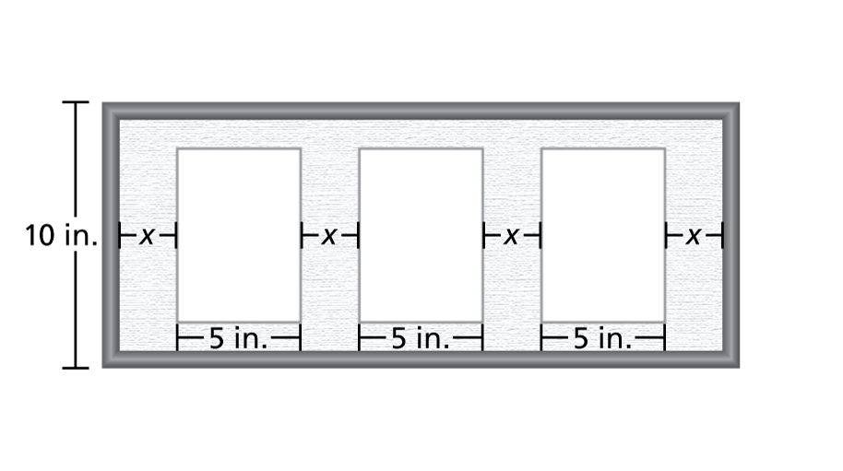

12. One page of a petition can hold *p* signatures. You were able to   
get people to sign the petition. Your friend was able to   
get people to sign the petition. Write an expression that represents the number of people that you and your friend got to   
sign the petition.

Name Date

Answers

13.

14.

15.

16.

17.

18.

19.

20.

21.

22.

23.

24.

25.

26.

Test A **(continued)**

Chapter

13

Solve the equation. Check your solution.

13.  14. 

15.  16. 

17.  18. 

Write the word sentence as an equation. Then solve.

19. 11 more than a number *q* is negative 15.

20. The difference of a number *m* and 30 is 10.

21. One-third of a number *t* is equal to 7.

22. The quotient of 5 plus a number *d* and negative 2 is 14.

In Exercises 23–26, write an equation. Then solve.

23. The temperature is  A high pressure front increases the temperature to  By how many degrees did the temperature increase?

24. The monthly dues for a premium membership at a health club is   
$15 more than the cost of a standard membership. The premium membership is $40 per month. What is the cost of a standard membership?

25. A pack of cardinal flower seeds costs $4, and a pack of petunia   
flower seeds costs $2.50. You buy the same number of packs of   
each type of flower and spend $39. How many packs of each do   
you buy?

26. An egg carton holds 12 eggs. A breakfast buffet uses 96 eggs by   
8 a.m. When the buffet ends at 10:30 a.m., a total of 156 eggs were used. How many cartons of eggs were used after 8 a.m.?