9.4: Volumes of Prisms

*The Volume of a 3-dimensional figure is a measure of the amount of space that it occupies. Volume is measured in cubic units.*

Volume of a Prism

V = Bh (area of the base times the height)

Find the volume of the prism.

1. 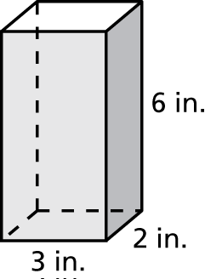 2. 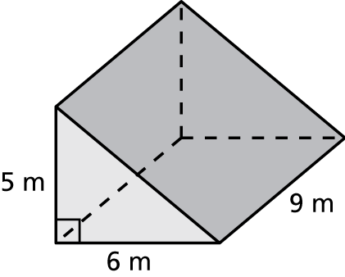

3. 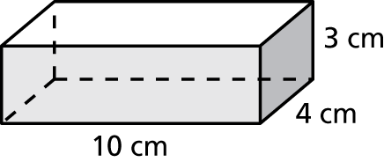 4. 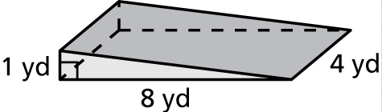

5. 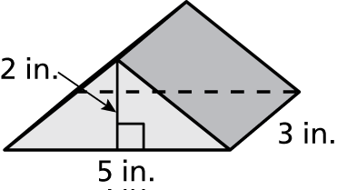 6. 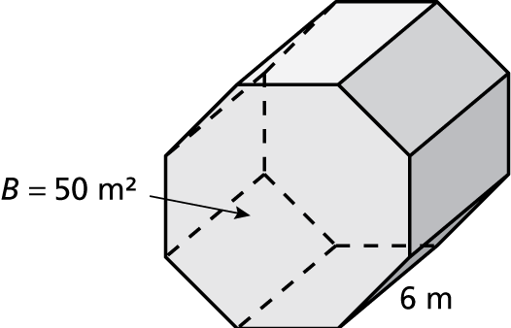

7. A cell phone is in the shape of a rectangular prism, with a length of 4 inches, a width of 2 inches, and a height of 1 inch. What is the volume of the cell phone?

8. A recycle bin is in the shape of a trapezoidal prism. The area of the base is 220 square inches and the height is 24 inches. What is the volume of the recycle bin?

9. A water jug is in the shape of a prism. The area of the base is 100 square inches and the height is 20 inches. How many gallons of water will the water jug hold?  Round your answer to the nearest tenth.