The Principal’s Challenge starts NEXT WEEK!
Get your kids registered for this amazing program where they get to
train for the 5K/One Mile Fun Run with Mr. Mazzini!

COUNTY ROAD SCHOOL – Starts Thursday, March 28th
Meets 1 x week on Thursdays from 3:05 – 4:00pm

For more information and to register go to:
www.demarest5k.org

Thank you to our Principal’s Challenge Title Sponsor:

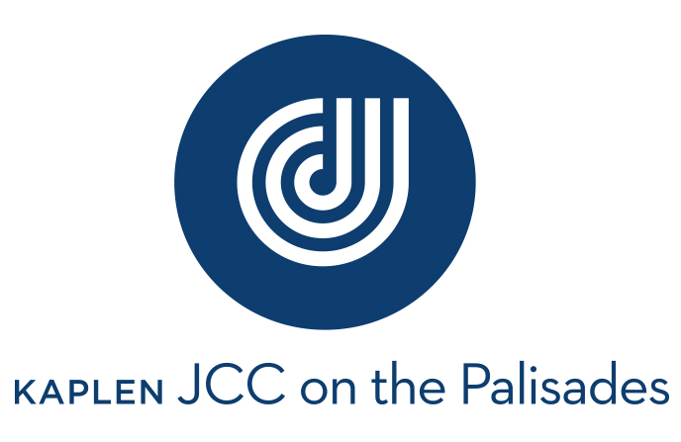

Trainers from the JCC will be attending sessions and helping
to train the students through fun exercises and drills!

PASTA NIGHT FOR PRINCIPAL’S CHALLENGE FAMILIES!!
The Korean Demarest Parents Association has generously offered to host a
pasta night for our Principal’s Challenge families, Saturday, May 18th, 2019.
More information to follow!

