Letter to Next Year’s Students

**HOMEWORK:**

**MC900352181[1]Type a detailed one-page letter with three paragraphs to a future student of my classroom. Your purpose is to inform next year’s students about 6th Grade Language Arts. Follow the friendly letter format that we discussed in class. This will be the first thing they read next year! ☺**

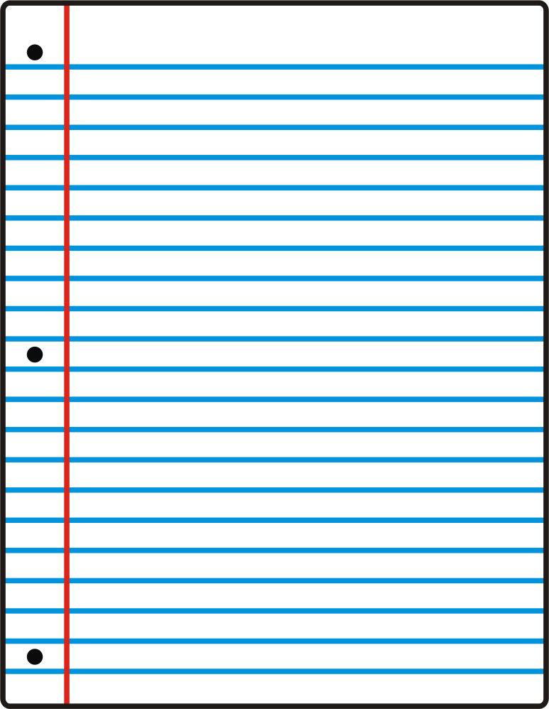

Dear Future Student of _________,

**Paragraph #1-Introduce yourself & what students will learn in this class.**

* My name is…
* In this class, we learned…(BE SPECIFIC)
* I had the most fun learning about…(BE SPECIFIC)

**Paragraph #2-Favorite Memories/Projects**

* My favorite project was…
* In this project, we…
* My favorite memory was when…(BE SPECIFIC)

**Paragraph #3-Advice/tips/inspiration for future students**

* To be successful in this class, you need to…
* One piece of advice I have is…
* My overall best tip is…

Sincerely, _____(Your Name)_______